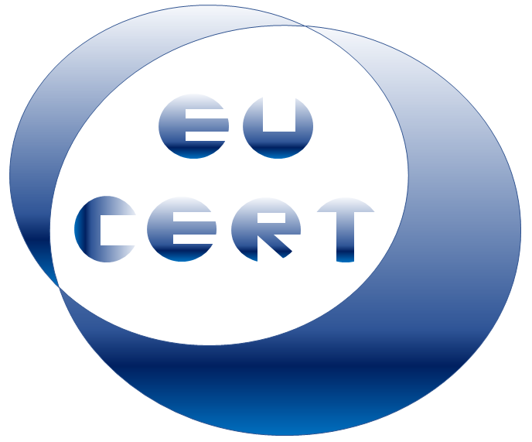
EU-CERT
European Certificates and Accreditation for European Projects

Agenda for the first EU-CERT transnational partner meeting
in Germany, Cologne
The EU-CERT – Kick-off-Conference!
11th - 13th of April 2022

Project Title: European Certificates and Accreditation for European Projects
Acronym: EU-CERT
Reference number: 2021-1-DE02-KA220-ADU-000033541
Project partners:
P1 University Paderborn (UPB), DE
P2 Ingenious Knowledge GmbH (IK), DE
P3 Associação Rede de Universidades da Terceira Idade (RUTIS), PT
P4 TIR Consulting Group j.d.o.o., (TIR), CR
P5 Esquare (ESQ), FR
P6 STANDO Ltd. (STANDO), CY

Host: Ingenious Knowledge GmbH
Venue: Friedrich-Karl-Straße 200, 50735 Cologne, Germany
Monday, 11th of April 2022 –
Arrivial day
Approx.  Time | Topic | Chair
as you like | Arrival at the hotels in Cologne
19:30 | Social Dinner  venue / restaurant:  Niehler Brauhaus, Sebastianstraße 147, 50735 Köln

Tuesday, 12th of April 2022 –
Meeting day
Approx.  Time | Topic | Chair
09:00 – 10:30 | Welcoming the EU-CERT partners  (Rasmus Pechuel / Marc Beutner)  - Warm welcome  - Getting to know each other  - Every partner presents the own institution in max. 10 minutes Power-Point presentation  - Schedule of the meeting | IK / UPB/  All partners
10:30 – 11:00 | Introduction of the EU-CERT project  (Marc Beutner / Jennifer Schneider)  - Rationale, purpose, core ideas and aims of the project  - Role of the partners as per proposal  - Overview of the project results and linkages  - Project website  - Discussion, and Q&A | UPB
11:00 – 11.30 | Insight into PR1: EU-CERT - Research on Quality Criteria, Accreditation and Certificate Structures  (Marc Beutner / Jennifer Schneider)  - PR-Overview  - Tasks | UPB / STANDO

Approx.  Time | Topic | Chair
11:30 – 12:00 | Insight into PR2: EU-CERT - Concept Design for  Accreditation and Certification Processes  (Anna Nicolaou / Marc Beutner / Jennifer Schneider  - PR-Overview  - Tasks | STANDO / UPB
12:00 – 13:00 | Lunch
13:00 – 13:30 | Insight into PR3: EU-CERT - Accreditation Website  and Data-base Design and Programming  (Rasmus Pechuel)  - PR-Overview  - Tasks | IK
13:30 – 14:00 | Insight into PR4: EU-CERT - Accreditation Handbook  (Marc Beutner / Jennifer Schneider)  - PR-Overview  - Tasks | UPB
14:00 – 14:30 | Insight into PR5: EU-CERT - Accreditation and Certification - Roll-out to Adult Education Providers  (Soňa Štefková / Marc Beutner / Jennifer Schneider)  - PR-Overview  - Tasks | ESQ / UPB
14:30 – 15:00 | Insight into PR6: EU-CERT - Policy Paper  (Luis Jacob / Marc Beutner / Jennifer Schneider)  - PR-Overview  - Tasks | RUTIS / UPB
15:00 – 16:00 | Administrative and Financial Information  (Marc Beutner / Jennifer Schneider)  - Project management structure  - Documentary evidence required  - Online finance and project management tool (PROM) | UPB

Approx.  Time | Topic | Chair
16:00 – 16:30 | Dissemination and Exploitation  (Marc Beutner / Jennifer Schneider)  - The EU-CERT project website, social media  - Publications, Newspapers  - Ideas for the valorisation plan | All partners
16:30 – 17:00 | Meeting and Project Evaluation  (Jennifer Schneider)  - Quantitative indicators, evaluation approach, and evaluation framework  - Workshop evaluation | UPB
17:00 – 18:00 | Next- Steps - Wrap-up and Discussion on tasks to do |  | All partners

Wednesday, 12th of April 2022 –
Departure day
Approx.  Time | Topic | Chair
as you like | Have a safe trip home

Goodbye,
and let´s start into a great
EU-CERT project!

