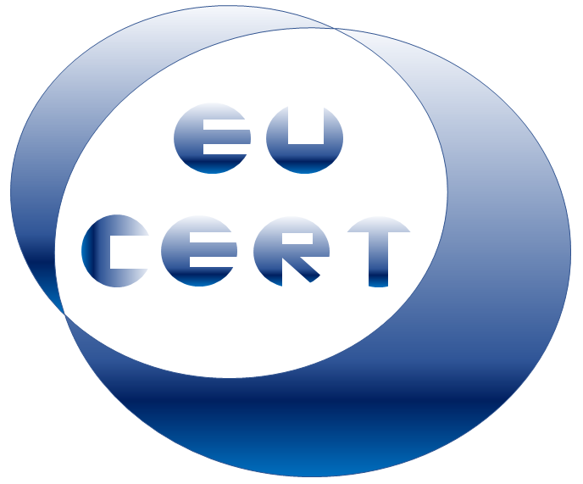
EU-CERT
European Certificates and Accreditation for European Projects

Agenda for the second EU-CERT transnational partner meeting
in Portugal, Lisbon
The EU-CERT – Accreditation Conference!
26th - 28th of October 2022

Project Title: European Certificates and Accreditation for European Projects
Acronym: EU-CERT
Reference number: 2021-1-DE02-KA220-ADU-000033541
Project partners:
P1 University Paderborn (UPB), DE
P2 Ingenious Knowledge GmbH (IK), DE
P3 Associação Rede de Universidades da Terceira Idade (RUTIS), PT
P4 TIR Consulting Group j.d.o.o., (TIR), CR
P5 Esquare (ESQ), FR
P6 STANDO Ltd. (STANDO), CY

Host: RUTIS
Venue: Rua Conde da Taipa, 40, 2080-069 Almeirim, Portugal
Wednesday, 26th of October 2022 –
Arrivial day
Approx.  Time | Topic | Chair
as you like | Arrival at the hotels in Almeirim

Thursday, 27th of October 2022 –
Meeting day
Approx.  Time | Topic | Chair
09:30 – 10:00 | Welcoming the EU-CERT partners  (RUTIS / Jennifer Schneider)  - Warm welcome  - Schedule of the meeting | Rutis / UPB/  All partners
10:00 – 10:30 | Current Status of the EU-CERT project  (Jennifer Schneider)  - Rationale, purpose, core ideas and aims of the project  - Role of the partners as per proposal  - Overview of the project results and linkages  - Project website, Discussion, and Q&A | UPB
10:30 – 11.00 | Insight into PR1: EU-CERT - Research on Quality Criteria, Accreditation and Certificate Structures  (Jennifer Schneider)  - PR-Overview  - Tasks | UPB
11:00 – 12.30 | Partner presentations on current work on  PR1: EU-CERT - Research on Quality Criteria, Accreditation and Certificate Structures  Every partner will provide a Power-Point-Presentation of about 5 to 10 minutes concerning the national status of EU-CERT and the current work on PR1 | All

Approx.  Time | Topic | Chair
12:30 – 13:30 | Lunch
13:30 – 14:00 | Insights into ideas for the Accreditation and Certification Concept  (Jennifer Schneider)  - PR-Overview  - Tasks | UPB
14:00 – 14:30 | Discussion on Accreditation and the concept idea  (Jennifer Schneider / Rasmus Pechuel) | All
14:30 – 15:00 | Ideas for EU-CERT - Accreditation Website  and Data-base Design and Programming  (Rasmus Pechuel)  - PR-Overview  - Tasks | IK
15:00 – 15:30 | Discussion on the Accreditation website  (Rasmus Pechuel) | All
15:30 – 16:30 | Administrative and Financial Information  (Rasmus Pechuel / Jennifer Schneider)  - Project management structure  - Documentary evidence required  - Online finance and project management tool (PROM) | IK/UPB
16:30 – 17:00 | Dissemination and Exploitation  (Jennifer Schneider)  - The EU-CERT project website, social media  - Publications, Newspapers  - Valorisation plan | All partners
19:30 | Social Dinner  venue / restaurant:  will be provided soon

Friday, 28th of April 2022 –
Departure day
Approx.  Time | Topic | Chair
09:30 – 10:00 | Next Steps  (Jennifer Schneider)  - What to do until the next meeting |  | UPB
10:00 – 11:00 | Meeting and Project Evaluation  (Jennifer Schneider)  - Quantitative indicators, evaluation approach, and evaluation framework  - Workshop evaluation |  | UPB
12.00 | Lunch for partners with later departure
as you like | Have a safe trip home

Goodbye,
and let´s start into the next phase of the
EU-CERT project!

