EU-CERT:
European Certificates and Accreditation for European Projects
Project Results 1 - Qualitative Research
(I) Desktop research in each partner country
March 2022

University of Paderborn
Jennifer Schneider

Acronym: EU-CERT
Reference number: 2021-1-DE02-KA220-ADU-000033541
Project duration: 01.02.2022 – 31.05.2024 (28 month)
Proj project partners: University of Paderborn (P0), Coordinator
Ingenious Knowledge GmbH (P1)
RUTIS-Associação Rede de Universidades da Terceira Idade (P2)
TIR Consulting Group j.d.o.o., Croatia (P3)
Esquare, France (P4)
STANDO LTD Cyprus (P5)

1. Project Results 1 - Qualitative Research

This project result 1 (PR1) provides deep research on existing certificate and quality assurance structures in the partner countries of EU-CERT.
It basis on the already existing needs analysis which was done before applying for this projects. The needs analysis gave a general overview on the accreditation and certification structure in adult education with regard to ERASMUS+. It should that there exist several general quality assurance solutions in the partner countries but that there is no focus no general accreditation process which takes the ERASMUS+ results into account and fosters transparency of the ERASMUS+ adult education programme. Also it was clear after the needs analysis that there is a variety of quality assurance approaches.
Our needs analysis before this application was a formal, systematic process of identifying and evaluating the need for such an certification and accreditation process in the field of adult education. It also showed that just a PDCA-cycle (Plan, Do, Check, Act) cannot be an adequate basis for future quality assurance and accreditation in adult education. This means, to design a feasible approach within EU-CERT, we need more detailed information about the existing processes.
To make sure that there are no double works and that existing structures will be taken under account the IO1 research of EU-CERT gathers the existing quality criteria and puts them together in a criteria matrix. Therefore, the certificate structures and quality criteria will be explained by experts in interviews to get a deeper insight and also existing accreditation processes are explained and documented.

Background of the needs analysis (Nov./ Dec. 2021):
more than 80% of the participants asked for evidences concerning the situation with regard to certification and accreditation in adult education
To take this need for serious we designed this first project result which ones with evidence derived from research in the partner countries.

2. Project Result 1 – Mixed- Methods Design of the Research

- The Erasmus+ Project EU-CERT aims to to enhance quality in adult education and helps to ensure that adult education providers are able to find high quality adult education results which can be used in practice and which base on excellent adult education projects.
Therefore, the project consortium is going to develop a mechanism to monitor the effectiveness of adult education project via an accreditation system which is based on clear criteria and a solid accreditation procedure.
To guarantee a multiperspective research and evaluation of the results, the consortium agrees to stick to a Mixed- Methods Design for the EU-CERT project research.

Mixed- Methods Approach is the combination and integration of qualitative and quantitative methods within the same research project.
It is a research in which the researchers collect both qualitative and quantitative data within the framework of single- or multi-phase designs. The integration of both strands of methods, i.e. data, results and conclusions, takes place in the final phase of the research project or in earlier project phases, depending on the design. (See Kuckartz (2014), pp. 44ff.)

For the EU-CERT project, Mixed- Methods means the combination of a sequential research design witch starts with a (I) Qualitative Research, followed by an quantitative questionnaire research. This research approach is defined as exploratory research design in scientific background, too.
An exploratory research approaches helps to generate first results to understand the overall background of the identified problem. It can be adapted into different study structures and are flexible in addressing different types of research questions.
Moreover, with the first step by evaluating the qualitative research results, questions like what? and why? can be focused and clarified.
At least it helps to establish research priorities for further research studies and helps to select relevant findings for guidance and recommended actions.

(I) Qualitative Research (QUAL)
The qualitative research is divided in a first qualitative desktop research to generate information and results about quality criteria in accreditation systems as well as information about existing accreditation procedures. These results will be the basic of creating the interview guide for the expert interviews, to get new, rudiment information about opinions, needs and perspectives about existing accreditation processes and quality needs and standards. Every partner of the consortium will conduct at least 5 expert interviews in their partner country.

(II) Quantitative Research (QUAN)
After the first qualitative research the second part of the evaluation deals with a quantitative survey questionnaire, based on the desktop results as well as qualitative interview results. The survey is available in all partner languages and reach at least 25 stakeholders in each country.

Merging both research results:
(I) Qualitative Research Results and (II) Quantitative Research Results
The following figure shows the interconnection of the three methods the EU-CERT Project Result 1 takes into account to reach
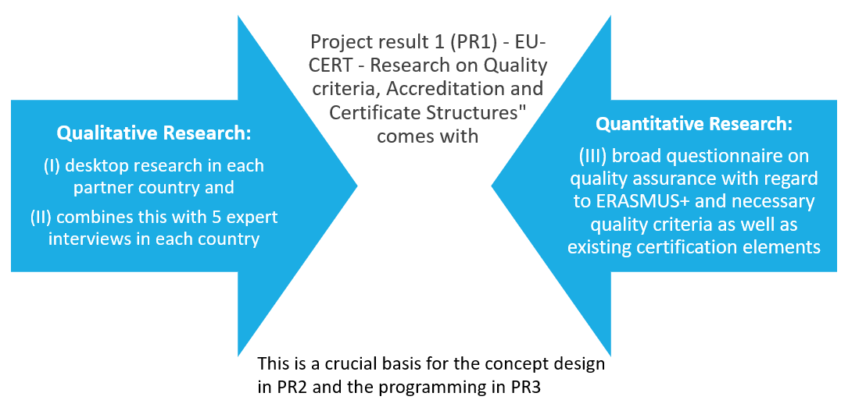
Figure 1 Mixed- Methods Approach of EU-CERT.

(I) Project Result 1 – Qualitative Research
(I.I) Desktop research in each partner country

Task: Deep research on existing certificate and quality assurance structures in the partner countries of EU-CERT.
1. What are the common existing certificates in your country?

2. How is the quality assurance structure of the certificates in your countries?

References:
Döring, N.; Bortz, J. (2016): Forschungsmethoden und Evaluation in den Sozial- und Humanwissenschaften, 5. Auflage, Springer Verlag.
Kelle, U. (2017): Die Integration qualitativer und quantitativer Forschung – theoretische Grundlagen von „Mixed Methods“, In: Kölner Zeitschrift für Soziologie und Sozialpsychologie, Springer Fachmedien GmbH.
Kuckartz, U. (2014): Mixed Methods. Methodologie, Forschungsdesigns und Analyseverfahren. Wiesbaden: Springer VS für Sozialwissenschaften.

