EU-CERT:
European Certificates and Accreditation for European Projects
Project Results 1 - Qualitative Research
(I) Desktop research in each partner country
March 2022

University of Paderborn
Jennifer Schneider

Acronym: EU-CERT
Reference number: 2021-1-DE02-KA220-ADU-000033541
Project duration: 01.02.2022 – 31.05.2024 (28 month)
Proj project partners: University of Paderborn (P0), Coordinator
Ingenious Knowledge GmbH (P1)
RUTIS-Associação Rede de Universidades da Terceira Idade (P2)
TIR Consulting Group j.d.o.o., Kroatien (P3)
Esquare, Frankreich (P4)
STANDO LTD Cyprus (P5)

1. Project Results 1 - Qualitative Research

This project result 1 (PR1) provides deep research on existing certificate and quality assurance structures in the partner countries of EU-CERT.
It basis on the already existing needs analysis which was done before applying for this projects. The needs analysis gave a general overview on the accreditation and certification structure in adult education with regard to ERASMUS+. It should that there exist several general quality assureance solutions in the partner countries but that there is no focus no general accreditation process which takes the ERASMUS+ results into account and fosters transparency of the ERASMUS+ adult education programme. Also it was clear after the needs analysis that there is a variety of quality assurance approaches.
Our needs analysis before this application was a formal, systematic process of identifying and evaluating the need for such an certification and accreditation process in the field of adult education. It also showed that just a PDCA-cycle (Plan, Do, Check, Act) cannot be an adequate basis for future quality assurance and accreditation in adult education. This means, to design a feasible approach within EU-CERT, we need more detailed information about the existing processes.
To make sure that there are no double works and that existing structures will be taken under account the IO1 research of EU-CERT gathers the existing quality criteria and puts them together in a criteria matrix. Therefore, the certificate structures and quality criteria will be explained by experts in interviews to get a deeper insight and also existing accreditation processes are explained and documented.

Background of the needs analysis (Nov./ Dec. 2021):
more than 80% of the participants asked for evidences concerning the situation with regard to certification and accreditation in adult education
To take this need for serious we designed this first project result which ones with evidence derived from research in the partner countries.

2. Project Result 1 – Mixed- Methods Design of the Research

- The Erasmus+ Project EU-CERT aims to to enhance quality in adult education and helps to ensure that adult education providers are able to find high quality adult education results which can be used in practice and which base on excellent adult education projects.
Therefore, the project consortium is going to develop a mechanism to monitor the effectiveness of adult education project via an accreditation system which is based on clear criteria and a solid accreditation procedure.
To guarantee a multiperspective research an evaluation of the

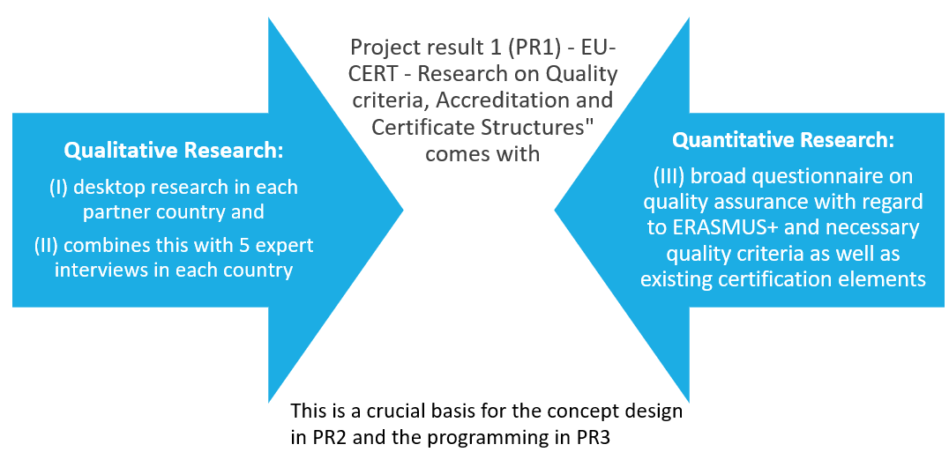

Formula guideline for the analysis
of a certification sytsem of adult education programs
on the basis
of different criteria of quality

2022
Carl Ritter

Study Programme: Internship Ingenious Knowledge
European project EU-CERT

Don´t hesitate to contact us if there are any questions.
We will be happy to provide you with any help you need.

General Information

This guideline with questions is part of the European project EU-CERT and aims to facilitate the analysis of certification systems and the establishment of quality criteria after the evaluation of the guideline.
The guideline is part of an evaluation as well as analysis and therefore it is important to fill in full sentences and not only some keyword. Please, be so kind and answer as complete as possible and provide examples wherever possible. The guideline comes with open questions in the end where you provide free text, as well as questions where you are asked to do a ranking or rating.
The guideline is used by project partners of the European project EU-CERT. The analysis focusses on the development of a mechanism to monitor the effectiveness of adult education projects. WIth the help of the guideline an accreditation system is developed which is based on clear criteria that are also integrated in the guideline formula and the questions. After the evaluation phase, an accreditation certificate can be elaborated with the help of which adult education can be certified concerning its quality. The certificate can be used as a proof for high or excellent quality of adult education programs.

General instructions for completing the questionnaire:
This guideline consists of a quantitative and qualitative parts and addresses three thematic sections:
- General information
- Estimations and Ratings about adult education programs
- Qualitative open questions on individual views on adult education programs
- Opportunities and Challenges

To handle all questions, you need approximately 20 minutes.
All your information will be analysed and evaluated completely anonymously.
For any further questions, we are at your disposal.
You can reach us and find more important information on our website.

General Information
Gender – I am …

Female | ⚪
Male | ⚪
Rather not say | ⚪
Other / Diverse | ⚪

Age

Below 20 | ⚪
21-30 | ⚪
31-40 | ⚪
41-50 | ⚪
51-60 | ⚪
Over 60 | ⚪

Status – I am …

a trainer/teacher (adult education) | ⚪
a student teacher | ⚪
Other: | ⚪

Status – I am active …

at a secondary school: Gymnasium | ⚪
at a secondary school: Gesamtschule | ⚪
at a secondary school: Realschule | ⚪
at a secondary school: Hauptschule | ⚪
at a vocational school | ⚪
at university as a student teacher | ⚪
Other | ⚪

Estimations and ratings about adult education programs
In how far are the following criteria integrated in the adult education program [AEP]? (please make a first mark with a cross in each line)
Are the criteria of a specific relevance for the adult education program? (please make a second mark with a cross in each line)

 | first mark  with a cross |  |  | second mark  with a cross
 | The criteria is completely integrated in the EAP | The criteria is partly integrated in the EAP | The criteria is not integrated in the EAP | The criteria is of specific relevance for the EAP | The criteria is not of specific relevance for the EAP
Effective strategies for enhancing basic skills | ⚪ | ⚪ | ⚪ | ⚪ | ⚪
Development of basic and transversal skills by using innovative methods | ⚪ | ⚪ | ⚪ | ⚪ | ⚪
High competence of the adult educator | ⚪ | ⚪ | ⚪ | ⚪ | ⚪
Contribution to the development of a European area of skills and qualifications | ⚪ | ⚪ | ⚪ | ⚪ | ⚪
Inclusive approaches of adult education programs | ⚪ | ⚪ | ⚪ | ⚪ | ⚪
Support of general Europan values and shared values of democracy | ⚪ | ⚪ | ⚪ | ⚪ | ⚪

How important is the content of the AEP against the background of the necessity of raising international awareness also in terms of EU-Citizenships?
Rate with one cross on a scale from 1 to 10 (1 – unimportant to 10 – important)

1 | 2 | 3 | 4 | 5 | 6 | 7 | 8 | 9 | 10
⚪ | ⚪ | ⚪ | ⚪ | ⚪ | ⚪ | ⚪ | ⚪ | ⚪ | ⚪

How important will the content of the AEP be in five years concerning the current social, political as well as economic developments?
Rate with one cross on a scale from 1 to 10 (1 – unimportant to 10 – important)

1 | 2 | 3 | 4 | 5 | 6 | 7 | 8 | 9 | 10
⚪ | ⚪ | ⚪ | ⚪ | ⚪ | ⚪ | ⚪ | ⚪ | ⚪ | ⚪

In how far does the AEP focus on the enhancement of digital teaching and learning also in terms of the strengthening of education and training paths of educators and youth workers? (Please, make one cross in each line.)

 | strongly  represented | represented | rather rejected | strongly rejected
The educators work with digital media during the AEP sessions | ⚪ | ⚪ | ⚪ | ⚪
The AEP is part of a learning platform and is absolved by the participants in a digital way | ⚪ | ⚪ | ⚪ | ⚪
The communication between educators and participants is of intersocial as well as digital nature | ⚪ | ⚪ | ⚪ | ⚪
The participants learn about the use of digital media and its efficient application in their specific field of interest | ⚪ | ⚪ | ⚪ | ⚪
The educator is able to help the participants with problems concerning digital work and use of digital media | ⚪ | ⚪ | ⚪ | ⚪
The participants can acquire different ways of working digitally by experiencing digital work as presented methods during the AEP | ⚪ | ⚪ | ⚪ | ⚪
The participants strengthen their digital competences as important soft skills in their work environment | ⚪ | ⚪ | ⚪ | ⚪

How important are the following aspects of AEPs concerning their individual quality?
In general the AEP focuses on the importance of the quality criteria of … (Please, make one cross in each line.)

 | very  important | important | less important | unimportant
… the increasement of the efficiency of public expenditure and the appropriate investments in education, training and youth work by dealing with urgent social, political or educational issues | ⚪ | ⚪ | ⚪ | ⚪
… presenting high quality learning opportunities by training participants in their basic skills, adapting the new acquired knowledge to the work-life and the necessities and demands in the individual work spheres of the participants | ⚪ | ⚪ | ⚪ | ⚪
… the promotion of entrepreneurship education and social entrepreneurship among the participants by deepening their insights and competences also in terms of entrepreneurship as a benefit for their individual work-life | ⚪ | ⚪ | ⚪ | ⚪
… the strengthening of quality by providing mobility as well as cross-border ad international cooperations in which the participants can take part | ⚪ | ⚪ | ⚪ | ⚪
… the open examination of foreign cultures and dealing with cultural differences and similarities by focusing on EU-citizenship and international shared values and identities | ⚪ | ⚪ | ⚪ | ⚪
Other aspects, please specify: ____________ | ⚪ | ⚪ | ⚪ | ⚪

Present a tendency!
The AEP focuses on … (Please, make one cross in each line.)

international content | ⚪ | ⚪ | ⚪ | ⚪ | ⚪ | ⚪ | regional content
digital communication | ⚪ | ⚪ | ⚪ | ⚪ | ⚪ | ⚪ | face-to-face interaction
cooperation with international enterprises | ⚪ | ⚪ | ⚪ | ⚪ | ⚪ | ⚪ | independent courses and programs
active participation in international exchange | ⚪ | ⚪ | ⚪ | ⚪ | ⚪ | ⚪ | the demands in the regional work-life of the participants
innovative teaching methods | ⚪ | ⚪ | ⚪ | ⚪ | ⚪ | ⚪ | classic teaching methods
specifically trained educators | ⚪ | ⚪ | ⚪ | ⚪ | ⚪ | ⚪ | broader trained educators which tutor each a variety of different courses and programs
useful extension of the participants individual soft skills for their individual working sphere | ⚪ | ⚪ | ⚪ | ⚪ | ⚪ | ⚪ | extension of a broader variety of skills of the participants
easy application of the course issues in the participants work life | ⚪ | ⚪ | ⚪ | ⚪ | ⚪ | ⚪ | general improvement of individual skills independent of demands at work

Qualitative open questions on your individual use of teaching methods

In how far are disparities in learning outcomes, which especially affect disadvantaged learners, reduced during the learning process in the AEP? (Please, write about half a page)

In how far does the AEP contribute to the European Union in terms of the empowerment of a shared internation European identity and participation in international affairs? (Please, write about half a page)

How close does the AEP cooperated with (international) enterprises to ensure the close connection to the work-life of the participants? (Please, write about half a page)

Is the European orientation and allignement of the AEP visible in some way as European funding, European partnership or promotion of European values and citizenship? (Please, write about half a page)

Opportunities and Challenges

What are the opportunities of the specific AEP?
(Please, write at least 6 lines.)

What are the challenges of the specific AEP?
(Please, write at least 6 lines.)

What are the most striking quality critieria of the specific AEP [e.g. international or European orientation, digital work, connection to work-life, promotion and extension of soft skills…]
(Please, write at least 6 lines.)

Do you want to provide other comments on the topic?

