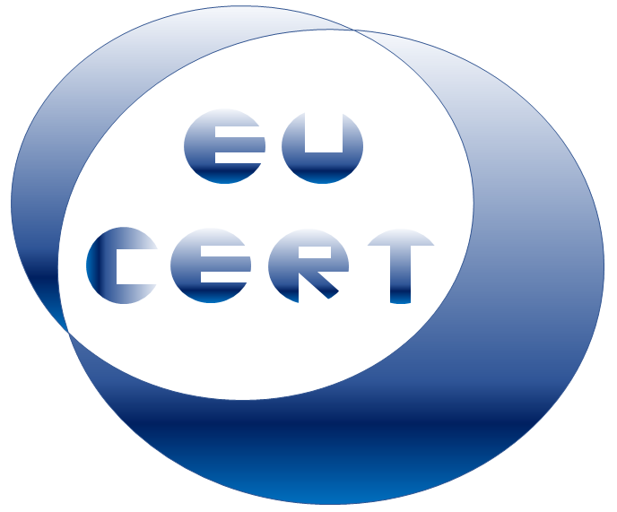
EU-CERT
European Certificates and Accreditation for European Projects

Agenda for the third EU-CERT transnational partner meeting
in France, Antibes
The EU-CERT – Accreditation Structure and Tool Conference!
7th - 9th of March 2023

Project Title: European Certificates and Accreditation for European Projects
Acronym: EU-CERT
Reference number: 2021-1-DE02-KA220-ADU-000033541
Project partners:
P1 University Paderborn (UPB), DE
P2 Ingenious Knowledge GmbH (IK), DE
P3 Associação Rede de Universidades da Terceira Idade (RUTIS), PT
P4 TIR Consulting Group j.d.o.o., (TIR), CR
P5 Esquare (ESQ), FR
P6 STANDO Ltd. (STANDO), CY

Host: Esquare (ESQ), France - https://e-square.fr/
Venue: The Originals Boutique, Hôtel Les Strélitzias, Antibes Ouest (Inter-Hotel),
2 Rue Pierre Commanay, 06160 Antibes, France
Tuesday, 7th of March 2023 –
Arrival day
Approx.  Time | Topic | Chair
as you like | Arrival at the hotels in Antibes

Wednesday, 8th of March 2023 –
Meeting day
Approx.  Time | Topic | Chair
09:45 – 10:00 | Welcoming the EU-CERT partners  (Soňa Štefková / Marc Beutner)  - Warm welcome  - Schedule of the meeting | Esquare /  UPB /  All partners
10:00 – 10:30 | Current Status of the EU-CERT project  (Marc Beutner)  - Rationale, purpose, core ideas and aims of the project  - Overview of the project results and linkages  - Project website, Discussion, and Q&A | UPB
10:30 – 11.30 | Current Status of the EU-CERT project in the partner countries / at the partner organisations –  Dissemination and integration  - 5 Minute PowerPoint presentation: Every partner presents the activities at the own institution in a max. 5 minutes  - Discussion | All
11:30 – 12.00 | Insight into PR1:  EU-CERT - Research on Quality Criteria, Accreditation and Certificate Structures  (Marc Beutner / Helene Lindenthal)  - PR-Overview  - Tasks | UPB

Approx.  Time | Topic | Chair
12:00 – 13:30 | Lunch
13:30 – 14:15 | Insight into PR2 and PR3:  EU-CERT - Concept design for accreditation and certification processes and the structure of the accreditation website  (Marc Beutner)  - PR-Overview  - Tasks | UPB / IK
14:15 – 14:45 | Discussion on the accreditation process  (Jennifer Schneider / Helene Lindenthal / Marc Beutner) | All
14:45 – 15:00 | Insight into PR4:  EU-CERT - Accreditation Handbook  (Marc Beutner / Helene Lindenthal)  - PR-Overview  - Tasks | IK
15:00 – 15:15 | Insight into PR5: EU-CERT - Accreditation and Certification - Roll-out to Adult Education Providers  (Soňa Štefková)  - PR-Overview  - Tasks | Esquare
15.15-15.30 | Insight into PR6 / PR7:  EU-CERT - Policy Paper and Layman´s Report  (Luis Jacob / Rajesh Pathak)  - PR-Overview  - Tasks | RUTIS / TIR
15:30 – 16:00 | Administrative and Financial Information  (Marc Beutner)  - Project management structure  - Documentary evidence required  - Online finance and project management tool (PROM) | IK/UPB
Approx.  Time | Topic | Chair
16:00 – 16:15 | Dissemination and Exploitation  (Helene Lindenthal)  - The EU-CERT project website, social media  - Publications, Newspapers  - Valorisation plan | All partners
16:15 – 16:30 | The Online Meeting Evaluation  (Helene Lindenthal)  - Workshop evaluation | UPB
16:30 – 17:00 | Next- Steps - Wrap-up and Discussion on tasks to do | All partners
19:30 | Social Dinner  https://www.plagelajetee.com/index.php/fr/brasserie-juan-les-pins

Thursday, 9th of March 2023 –
Departure day

Goodbye,
and let´s start into the next phase of the
EU-CERT project!

