Project title: EU CERT
Dissemination of KOM
Partner: Esquare
Date: 23.03.2023
Facebook – esquare company page
https://www.facebook.com/photo/?fbid=228624476356868&set=a.228624513023531
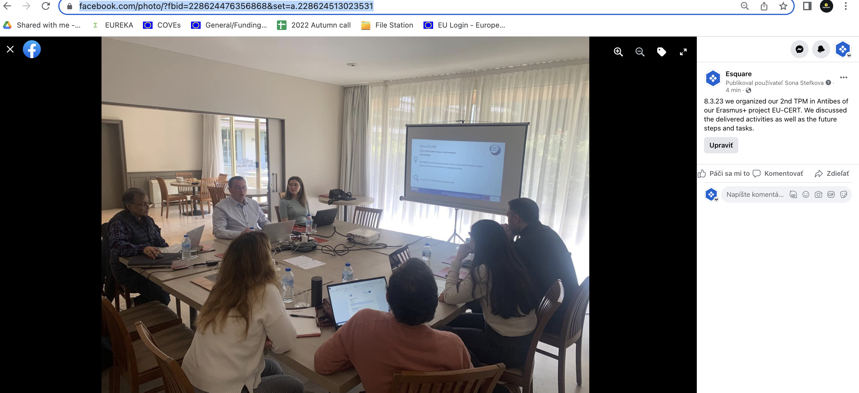
LinkedIn – esquare company page
https://www.linkedin.com/feed/update/urn:li:activity:7044640571642011648
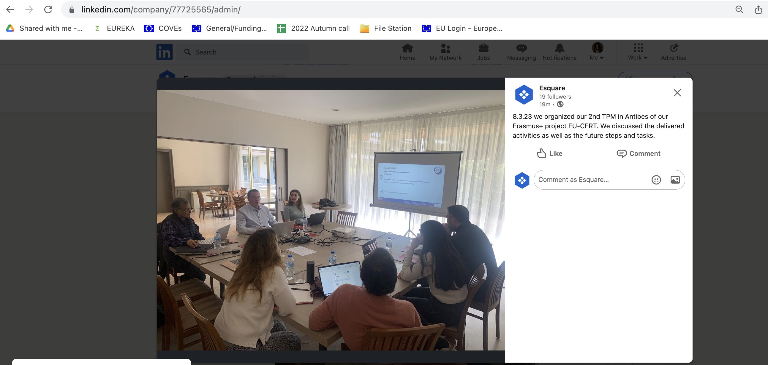
Instagram – esquare company page
https://www.instagram.com/p/CqIZmpMMPMn/?utm_source=ig_web_copy_link 