Project title: EU CERT
Dissemination of KOM
Partner: Esquare
Date: 12.04.2022
Facebook – esquare company page
https://www.facebook.com/Esquare-106911411857082/photos/pcb.139771698571053/139771575237732/
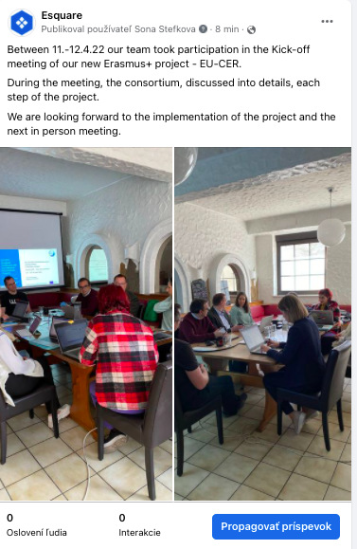

LinkedIn – esquare company page
https://www.linkedin.com/feed/update/urn:li:activity:6920422237376327680
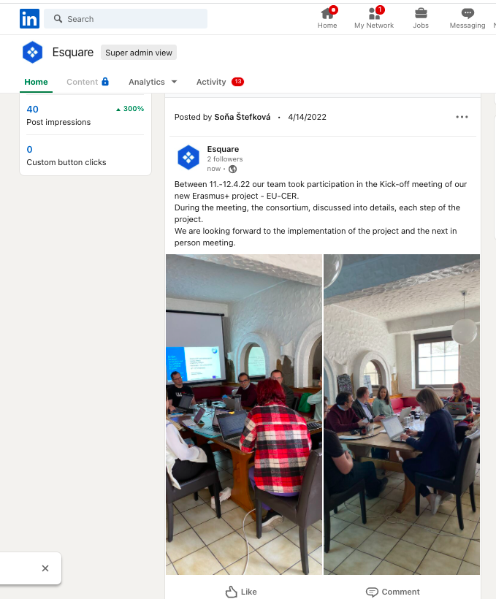

Instagram – esquare company page
https://www.instagram.com/p/CcVwm2dNMGg/?utm_source=ig_web_copy_link
