EU-CERT:
European Certificates and Accreditation for European Projects
Project Results 1 - Qualitative Research
(I) Desktop research in each partner country
March 2022

University of Paderborn
Jennifer Schneider

Acronym: EU-CERT
Reference number: 2021-1-DE02-KA220-ADU-000033541
Project duration: 01.02.2022 – 31.05.2024 (28 month)
Proj project partners: University of Paderborn (P0), Coordinator
Ingenious Knowledge GmbH (P1)
RUTIS-Associação Rede de Universidades da Terceira Idade (P2)
TIR Consulting Group j.d.o.o., Kroatien (P3)
Esquare, Frankreich (P4)
STANDO LTD Cyprus (P5)

1. Project Results 1 - Qualitative Research

This project result 1 (PR1) provides deep research on existing certificate and quality assurance structures in the partner countries of EU-CERT.
It basis on the already existing needs analysis which was done before applying for this projects. The needs analysis gave a general overview on the accreditation and certification structure in adult education with regard to ERASMUS+. It should that there exist several general quality assureance solutions in the partner countries but that there is no focus no general accreditation process which takes the ERASMUS+ results into account and fosters transparency of the ERASMUS+ adult education programme. Also it was clear after the needs analysis that there is a variety of quality assurance approaches.
Our needs analysis before this application was a formal, systematic process of identifying and evaluating the need for such an certification and accreditation process in the field of adult education. It also showed that just a PDCA-cycle (Plan, Do, Check, Act) cannot be an adequate basis for future quality assurance and accreditation in adult education. This means, to design a feasible approach within EU-CERT, we need more detailed information about the existing processes.
To make sure that there are no double works and that existing structures will be taken under account the IO1 research of EU-CERT gathers the existing quality criteria and puts them together in a criteria matrix. Therefore, the certificate structures and quality criteria will be explained by experts in interviews to get a deeper insight and also existing accreditation processes are explained and documented.

Background of the needs analysis (Nov./ Dec. 2021):
more than 80% of the participants asked for evidences concerning the situation with regard to certification and accreditation in adult education
🡪 To take this need for serious we designed this first project result which ones with evidence derived from research in the partner countries.

2. Project Result 1 – Mixed- Methods Design of the Research

- The Erasmus+ Project EU-CERT aims to to enhance quality in adult education and helps to ensure that adult education providers are able to find high quality adult education results which can be used in practice and which base on excellent adult education projects.
Therefore, the project consortium is going to develop a mechanism to monitor the effectiveness of adult education project via an accreditation system which is based on clear criteria and a solid accreditation procedure.
To guarantee a multiperspective research an evaluation of the

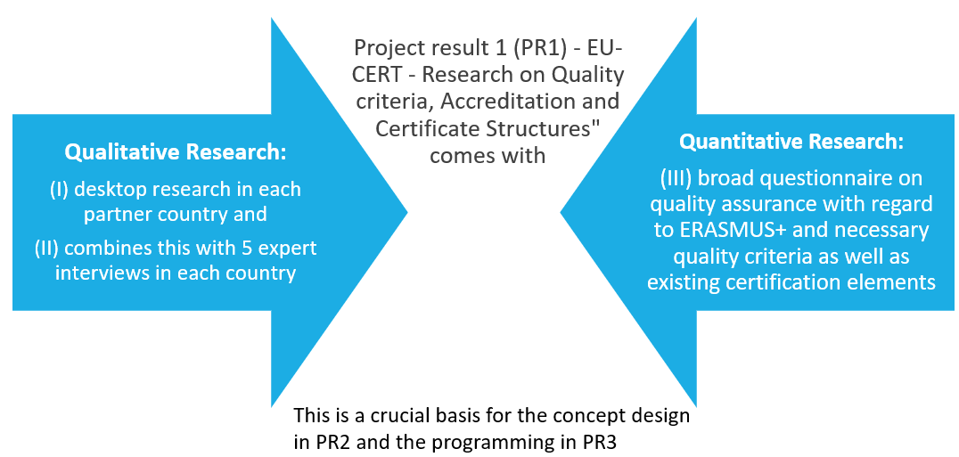

(II) Interviews in partner countries

Interview guideline for the analysis
of a certification system of adult education programs
on the basis
of different criteria of quality

2022
Carl Ritter

Study Programme: Internship Ingenious Knowledge
European project EU-CERT

General information

Dear Participant,
This interview guideline with open questions is part of the European project EU-CERT and contributes to the project by providing different opinions and views to facilitate the analysis of certification systems by identifying different quality criteria of adult education programs. The questions of the interview aim to find out these quality criteria which can form the basis of a general and adequate certification system for different adult education programs.
The guideline is part of a qualitative evaluation as well as analysis and therefore it is important to answer in full sentences and not only with some keyword. Please, be so kind and answer as complete as possible and provide examples wherever possible.
The interviews are conducted within the framework of the European project EU-CERT. The evaluation focusses on the development of a mechanism to monitor the effectiveness of adult education projects. With the help of the guideline an accreditation system is developed which is based on clear criteria that are also integrated in the guideline formula and the questions. After the evaluation phase, an accreditation certificate can be elaborated with the help of which adult education can be certified concerning its quality. The certificate can be used as a proof for high or excellent quality of adult education programs.
This is why it is very important to get to know your view on quality criteria of adult education programs and which factors can be used to measure their quality.
Let‘s start with some general instructions:

General instructions for completing the questionnaire:
This guideline consists of a quantitative and qualitative parts and addresses three thematic sections:
- General information
- Experiences with adult education and adult education programs
- Definition and assessment of adult education programs
- Criteria and factors to measure the quality of adult education programs
- Future outlook: Opportunities and Challenges of adult education

To handle all questions, you need approximately 20 minutes.
All your comments will be analysed and evaluated completely anonymously.
For any further questions, I am at your disposal. You can reach me via my email address and find more important information about the project on our website.

General information
The following questions serve the purpose to examine some background information about you as a person. By this your comments can be put into a context during the evaluation.
Please tell something about yourself, your profession and worklife as well as the enterprise, institution or school you are working at.
Please give also some short information about your gender and age group (e.g. between 30 and 40)

Experiences with adult education and adult education programs (AEP)
In how far have you already worked in the field of adult education?
What kind of adult education programs have you already experienced?
Which role did you have during the participation in an AEP (participant, educator, observer…)?

Definition and assessment of adult education
How do you define adult education?
What constitutes adult education for you?
Can you make out different forms of adult education?
Which forms have you already experienced yourself?
Please present some positive and negative aspects of the different forms of adult education.
How important is adult education for your individual work life?
Please comment on the following statements about the design of AEPs.
Do you agree or disagree? Please also give reasons.
Statement a)
Adult education programs should not focus on the training of basic skills of the participants but should rather improve their knowledge and competencies in specific areas of expertise.
Statement b)
Adult education programs should be internationally oriented which can be achieved by cooperations of adult education institutions and international companies.
Statement c)
Adult education programs need to focus on the individual needs of the participants and adequate content with connection to their work-life. International or rather European issues should not be discussed during the AEPs.
Statement d)
The educators of adult education programs need to have various competences in different fields of adult education and should not be specifically trained in one AE area or program.
How important will adult education be in five years?
Which different target groups are addressed within the framework of adult education programs?
In how far do AEPs focus on different learner types and also adapt the course design to disabled learners and participants?
Please give some positive and negative experiences and estimations.
Which aspects of adult education should be expanded in the near future. Which factors of adult education need to be improved? Please give reasons.
Which aspects of adult education should no longer be implemented so extensively as in the current measure? Please give reasons.
Are there any other aspects concerning adult education and its assessment you want to add?
Please present your opinion on current adult education programs. What goes well, what could be improved?
Please give a tendency concerning the following statements.
Current adult education programs are:
- important / unimportant
- interesting / uninteresting
- motivating / demotivating
- fun / boring
- innovative / conservative
- necessary / unnecessary
- with a strong / broad connection to the participants work-life
Which role does the educator have in different AEPs?
Are there different roles that need to be integrated in different AEPs and are taken over by the educator?
Criteria and factors to measure the quality of adult education programs
Can you identify different criteria which show a high or excellent quality of adult education programs?
Which criteria are important for employers to consider specific adult education programs as effective, necessary and of high quality?

Which criteria are important for employees to consider specific adult education programs as effective, necessary and of high quality?
Are there any further comments from your side on this topic of quality criteria of AEPs?

Future Outlook –
Opportunities and challenges of adult education
In how far should adult education programs be even more supported, also in a financial sense, so that their quality can be further increased in the future?
Which opportunities but also challenges can be seen in current adult education programs?
Which aspects should be further promoted?
Which challenges need to be overcome?

Which food for thought would you like to give concerning adult education in general and specific AEPs?

Thank you very much for your participation in the interview.
If you are interested in the research results, please send a short email. You will receive the results after the finalisation of the project.

