EU-CERT:
European Certificates and Accreditation for European Projects
Project Results 1 - (II) Quantitative Research (QUAN)
March 2022

STANDO CYPRUS

Acronym: EU-CERT
Reference number: 2021-1-DE02-KA220-ADU-000033541
Project duration: 01.02.2022 – 31.05.2024 (28 month)
Proj project partners: University of Paderborn (P0), Coordinator
Ingenious Knowledge GmbH (P1)
RUTIS-Associação Rede de Universidades da Terceira Idade (P2)
TIR Consulting Group j.d.o.o., Croatia (P3)
Esquare, France (P4)
STANDO LTD Cyprus (P5)

1. Project Results 1 - Qualitative Research

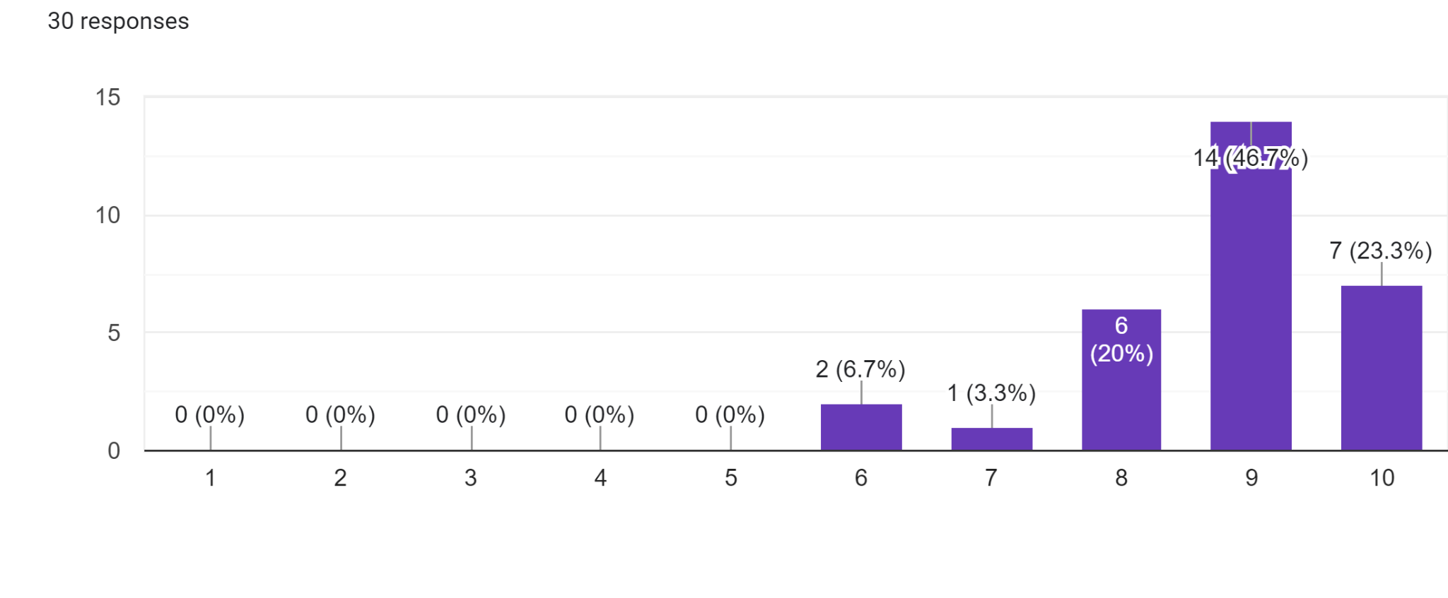
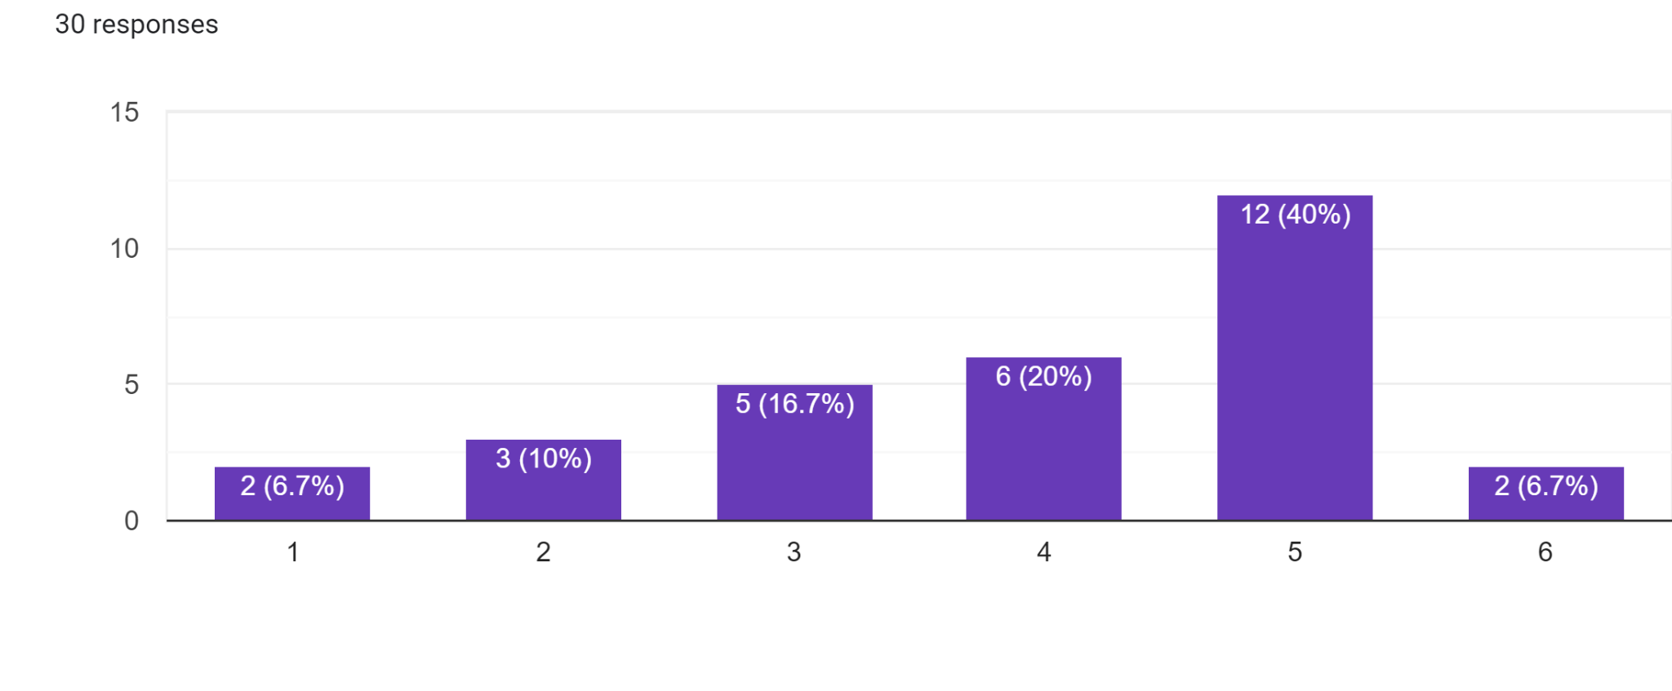

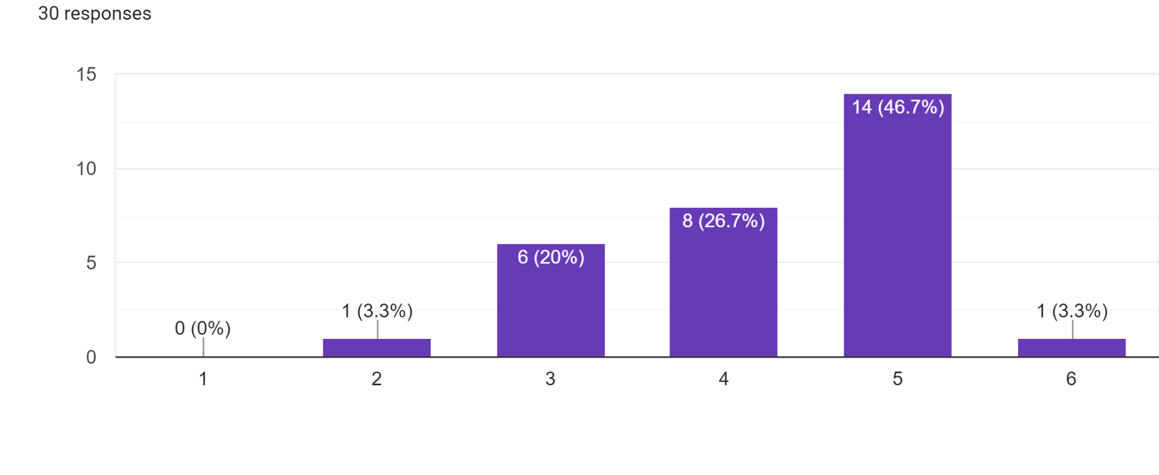

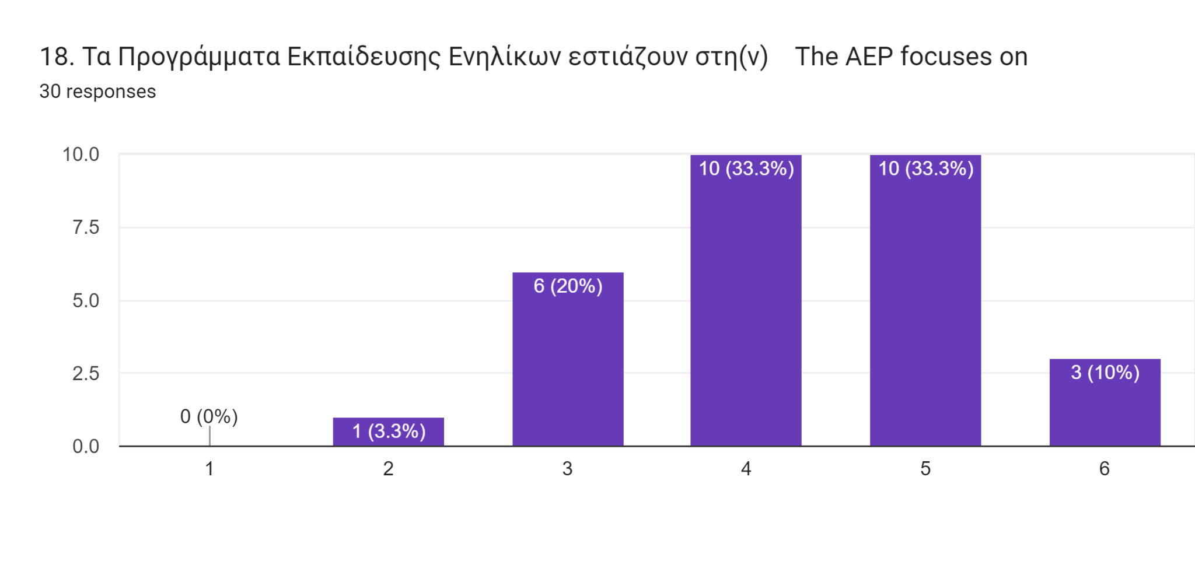
This is a Data analysis of the 30 questionnaires distributed to Cypriots.
30 Cypriots with experience in the field of adult education participated in this Broad Questionnaire to examine the quality assurance for ERASMUS+, and to determine the needed quality criteria. The questionnaire was created and distributed in Google Forms for an easier analysis, in both Greek and English. The questionnaire was divided into 3 sections and contained 28 questions, including 8 open-ended questions. The survey consisted of three sections, the first of which collected personal information, the second collected assessments and evaluations of the AEP's criteria, and the third and final section contained open-ended questions about their individual teaching techniques. Based on the data collected in the first section, a total of 26 participants in the survey are adult educators or trainers, most of whom work in vocational and adult education institutions. 6 of them are university students, and 3 are middle school educators, all of them involved in AEPs.
In the second section, participants had to rate the criteria on a multiple choice grid to determine whether they were fully, partially or not at all involved in AEP programmes. Implementation of effective strategies to improve basic skills is the first evaluation criteria. 55% of respondents said the criteria are fully addressed, while 45% said they are partially addressed. Regarding the second criterion, the development of basic and cross-cutting skills through innovative methods, 65% of respondents said that these criteria are partially integrated. The rest of the participants indicated that they are fully integrated. A third criterion concerns the level of competence of the adult educator. The majority of respondents (62%) stated that the criteria are partially integrated, while 4% reported that they are not incorporated at all.
A fourth criterion relates to the contribution to the development of a European area of competences and qualifications. 62% indicated that they are partially integrated, while 38% are fully integrated. The fifth criterion relates to the integrative nature of adult education programs. 48% of respondents indicated that the programs are fully integrated, while another

48% indicated that the programmes are partially integrated. A 6th criterion was the support for general European values and shared values of democracy in which 52% stated that they were completely integrated and 10% stated that they were not. Another question on a multiple-choice grid asked participants to rate the importance of certain criteria for AEPs.
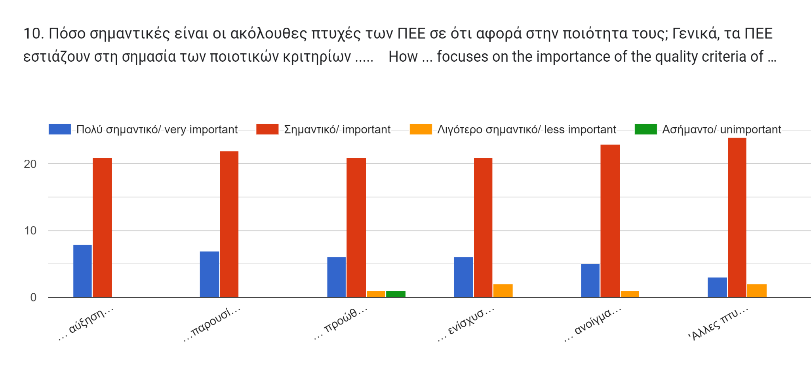
The chart below illustrates how important each quality criterion is. According to the color scheme, blue indicates that the criteria is very important, red indicates that it is important, yellow is less important, and green is unimportant. AEP programs take into account each of the criteria in a significant way, according to the majority of participants. From left to right, the criteria are as follows.
a) increasing the efficiency of public spending and the corresponding investment in education, training and youth work by addressing urgent social, political or educational issues
b) providing quality learning opportunities by training participants in their basic skills and adapting the newly acquired knowledge to the participants' everyday work and the necessities and requirements in their individual fields of work
(c) promoting entrepreneurship education and social entrepreneurship among participants by

deepening their insights and competences also in relation to entrepreneurship as a benefit for their individual working life
(d) strengthening quality through the provision of mobility and cross-border and international cooperation in which participants can participate
e) openly engaging with foreign cultures and dealing with cultural differences and commonalities by focusing on EU citizenship and international shared values and identities, are qualities considered important in the AEPs.
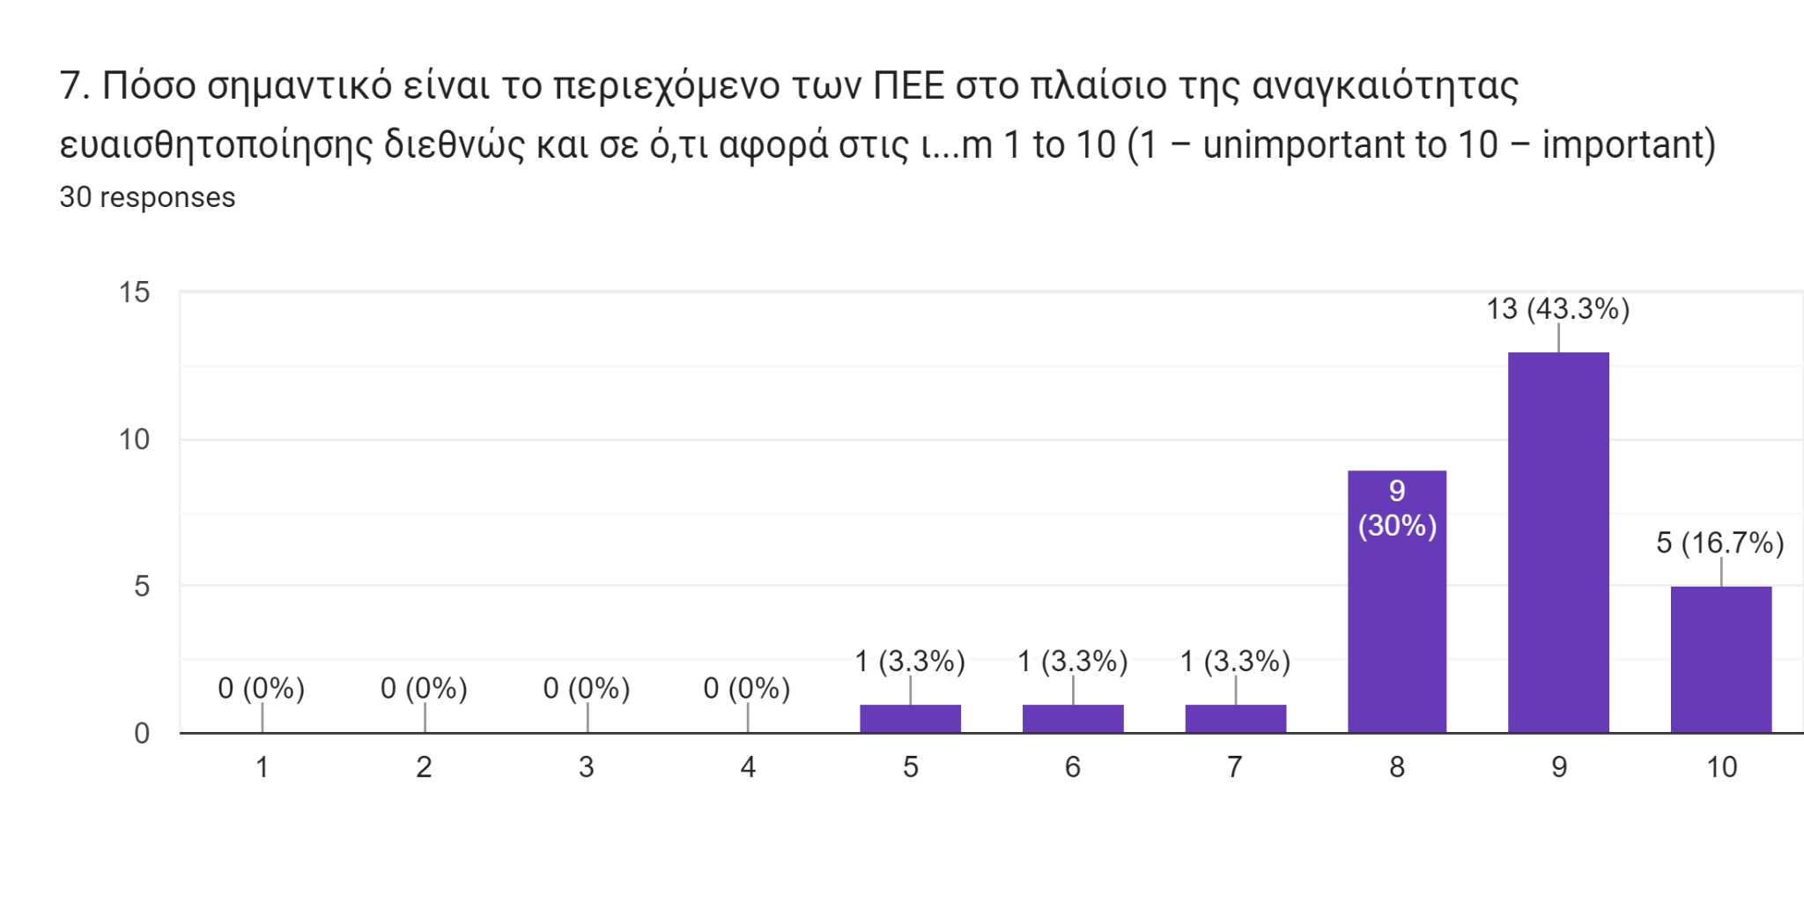
This part also contained scale questions. Based on a scale of 1-10, with one representing the least importance, this chart below displays participants' answers to the question of how important AEP is in raising international awareness about EU citizenship. 43% of participants rated it a 9 while 17% rated it a 10 and 30% rated it as an 8.
The charter below demonstrates the answers to the question on how important will the content of the AEP be in five years concerning the current social, political as well as economic developments. A majority of 80% rated it over 8 with 14 participants rating it 9.
The next section included scale questions ranging from 1 to 6 that indicated two different criteria. Regarding the AEP content focus on 1 being international and 6 being regional, 40% of the participants gave it a five. Another 20% rated it a 4, while 10 rated it between 1-3.
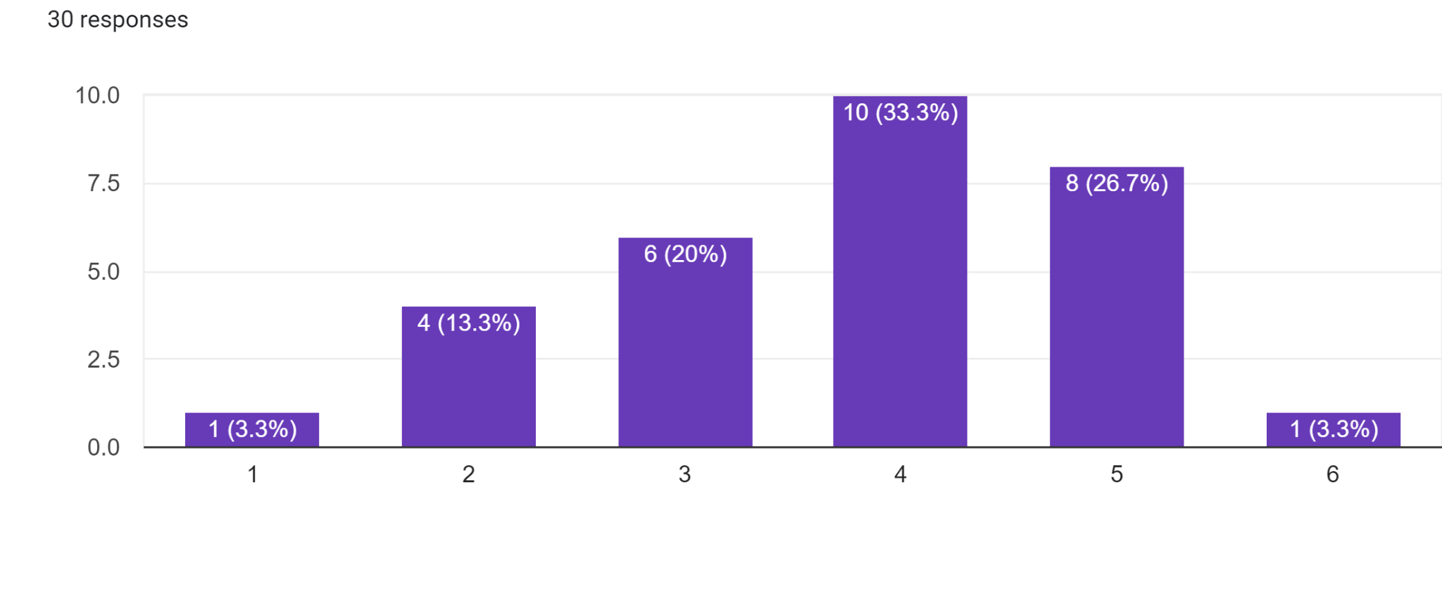
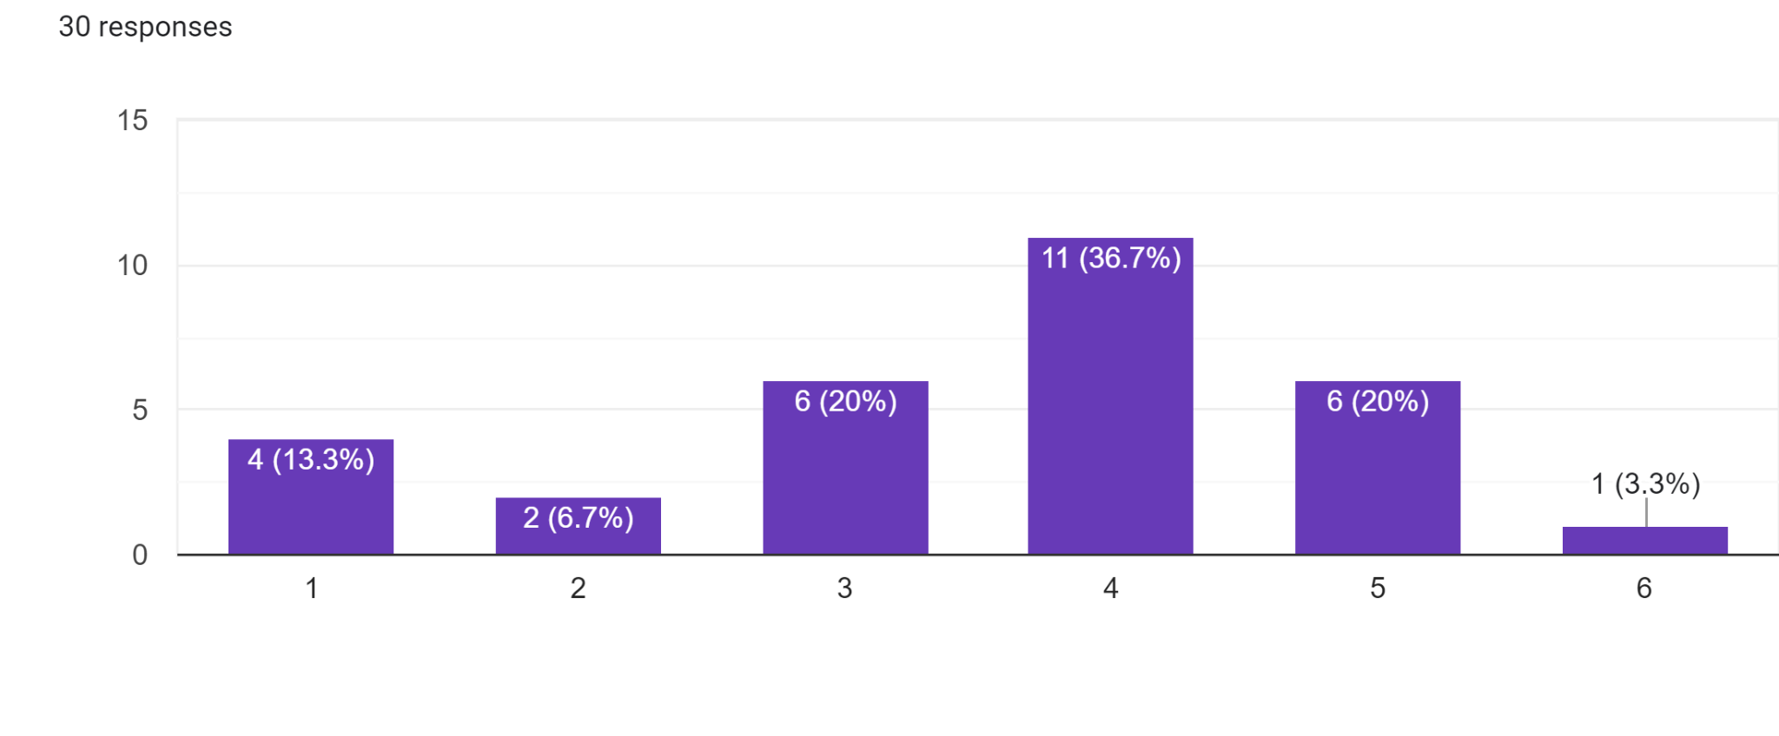
Below is a chart that shows the responses to the question whether the AEP emphasizes digital communication (1) or face-to-face interaction (6). Most participants rated it a 4, but another 20% rated it a 3 and 5 respectively.
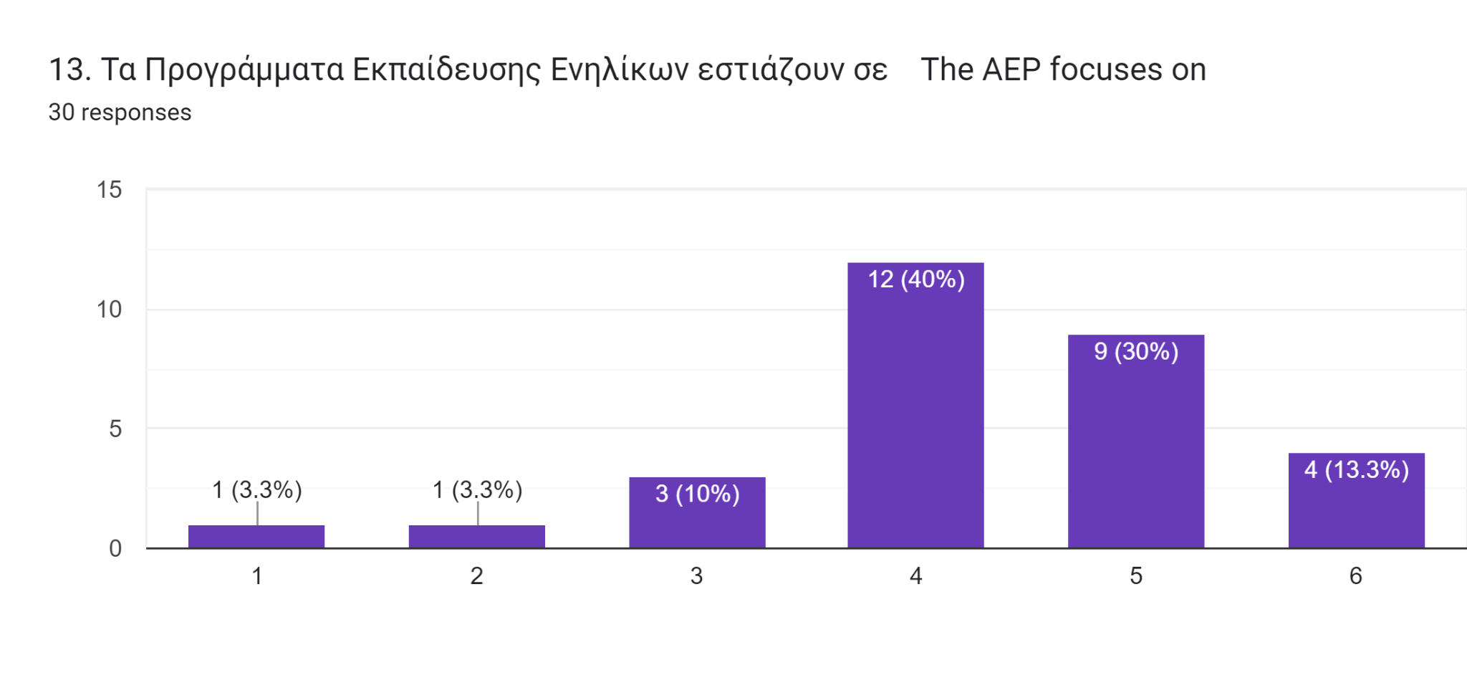
The chart below demonstrates the answers to whether the AEPs focus on cooperation with international enterprises (1) or active participation in international exchange (6). 40% of the participants rated it at number 4 and another 40% at 5.
The 14th question asked whether the AEPs focus more on active participation in international exchanges (1) or regional work demands (6). Among the participants, 33% classified it as 4, 27% classified it as 5 and 20% classified it as 3.
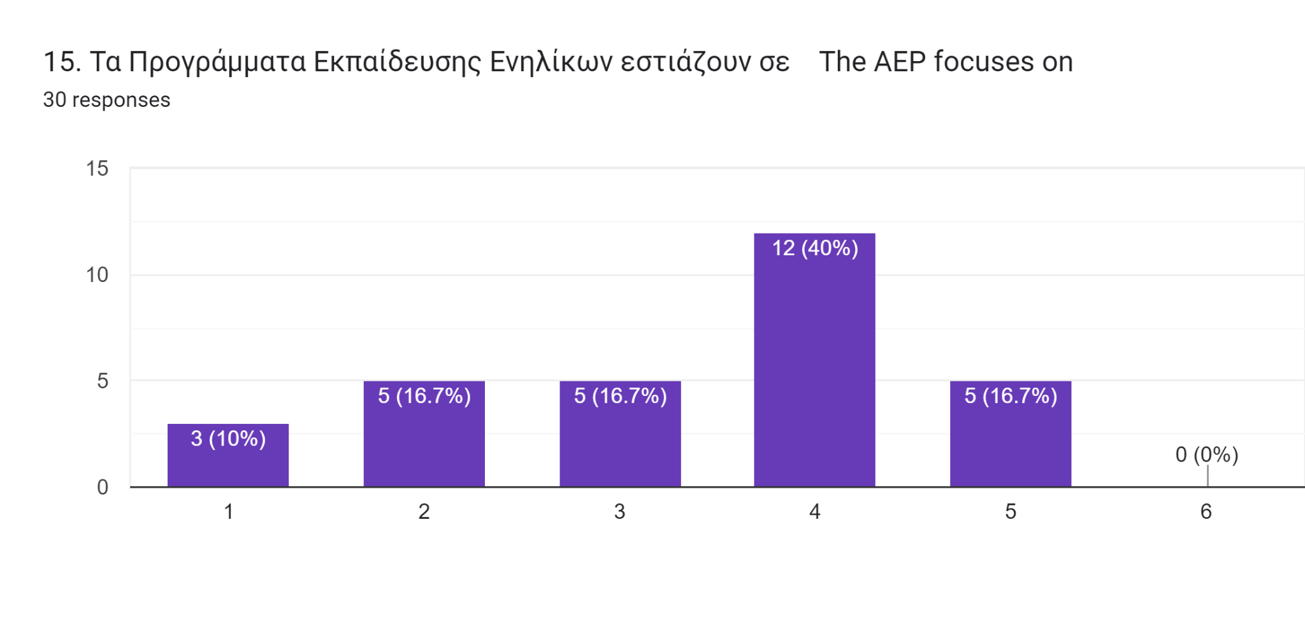
On the question whether the AEPs content focuses more on innovative teaching methods (1) or classic teaching methods (6) the majority rated it at 4. There were no answers at number 6.
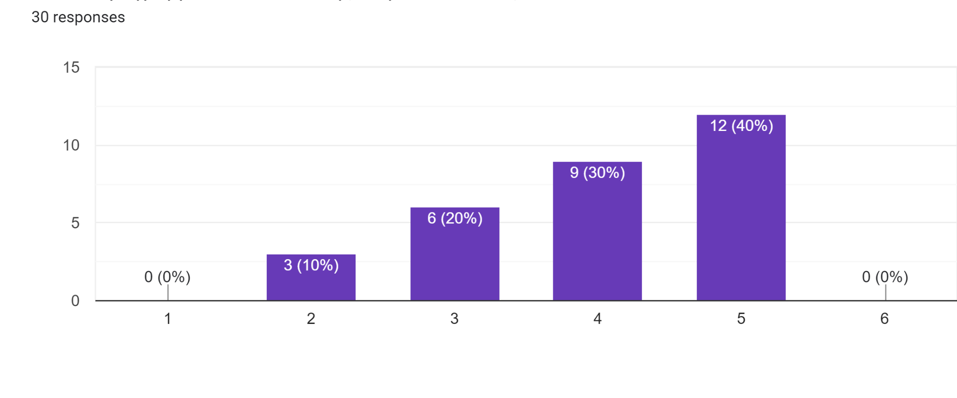
In response to the question of whether the AEP focuses on specially qualified educators (1) or more broadly trained educators (6), 23 participants lean to believe they focus on a broader range of skills.
When asked whether the AEP focuses more on enhancing participants' individual soft skills for their respective work area or on building a broader range of skills for participants, 23 respondents believe that there is a greater emphasis on the extension of a broader variety of skills for participants.
To the question if the AEPs focuses on easy application of the course issues in the participants' work life (1) or to the improvement of individual skills independent of demands at work (6), the majority of the responses on the scale were on number 4 and number 5.

In the final section of the questionnaire, participants were asked to discuss their own experiences regarding the AEPs, including criteria, opportunities, and challenges. The first question was whether the AEP reduces disparities in learning outcomes for disadvantaged learners. While some respondents believe that disparities in learning outcomes can be reduced during the learning process in the AEP, a substantial number of respondents indicated that the programs are not always inclusive of participants with disabilities and there are also instances where the training programs are not inclusive of trainers with disabilities. They also indicated that the more trained the trainer is in terms of inclusion the better the outcomes.
In response to the question of how far the AEP contributes to the European Union in terms of fostering a shared international European identity and participation in international affairs, all participants expressed similar views, including the ability to meet people of different backgrounds and interests, and exposure to different cultures. They stated that the

programmes offer them the opportunity to exchange ideas and develop an empowered international European identity.
As to how closely the AEP cooperates with (international) companies in order to ensure a close connection with the work lives of its participants, many participants responded that it depended on the program, while others expressed uncertainty about whether the level of collaboration was adequate. Other responses indicated that they worked closely, but others also indicated that improvements were necessary.
As indicated by the participants' responses, the European orientation and alignment of the AEP is evident in different ways, including funding, logos, acknowledgements, and the values that are promoted. As for the opportunities expressed by the participants were again similar, including exposure to new information, exchange of ideas with people with similar or different backgrounds and interests, exposure to new cultures, professional grow, lifelong learning opportunities

