EU-CERT:
European Certificates and Accreditation for European Projects
Dissemination Report Template
March 2022

University of Paderborn
Jennifer Schneider

Acronym: EU-CERT
Reference number: 2021-1-DE02-KA220-ADU-000033541
Project duration: 01.02.2022 – 31.05.2024 (28 month)
Proj project partners: University of Paderborn (P0), Coordinator
Ingenious Knowledge GmbH (P1)
RUTIS-Associação Rede de Universidades da Terceira Idade (P2)
TIR Consulting Group j.d.o.o., Kroatien (P3)
Esquare, Frankreich (P4)
STANDO LTD Cyprus (P5)

Please fill in your dissemination activities and archive your work with screenshots (see example)
PARTNER: e-square France
ONLINE
Publishing info/news on project’s website
Titles, short description, names, web-addresses etc. |  |  |  | Date and Place: |  |  |  | Target Group(s): |  | Numbers Reached: | Kind of documentation available |  |  | Level (L = local; R = regional; N = national; E = EU; O = Outside EU )
New poster are available |  |  |  | 11.06.2021  On Facebook |  |  |  | All interested readers, teachers, learners and students |  | >500 | … |  |  | L/ R/ N/ E
Establishment of relevant links to the EU-CERT website from other sites
Titles, short description, names, web-addresses etc. |  | Date and Place: |  |  |  | Target Group(s): |  |  | Numbers Reached: |  | Kind of documentation available |  |  | Level (L = local; R = regional; N = national; E = EU; O = Outside EU )
Distribution of digital newsletters, announcements, and info via e-mail
Titles, short description, names, web-addresses etc. |  | Date and Place: |  |  |  | Target Group(s): |  |  | Numbers Reached: |  | Kind of documentation available |  |  | Level (L = local; R = regional; N = national; E = EU; O = Outside EU )
Use of online social networks to disseminate EU-CERT info
Titles, short description, names, web-addresses etc. |  | Date and Place: |  |  |  | Target Group(s): |  |  | Numbers Reached: |  | Kind of documentation available |  |  | Level (L = local; R = regional; N = national; E = EU; O = Outside EU )
KOM meeting/FB post |  | 12.04.22 |  |  |  | All interested readers, teachers, learners and students |  |  | 26 |  | https://www.facebook.com/Esquare-106911411857082/photos/pcb.139771698571053/139771575237732/ |  |  | EU
KOM meeting/IG post |  | 12.04.22 |  |  |  | All interested readers, teachers, learners and students |  |  | 6 |  | https://www.instagram.com/p/CcVwm2dNMGg/ |  |  | EU
KOM meeting/LinkedeIn post |  | 12.04.22 |  |  |  | All interested readers, teachers, learners and students |  |  | 12 |  | https://www.linkedin.com/feed/update/urn:li:activity:6920422237376327680 |  |  | EU
2. TPM Antibes/FB post |  | 23.3.23 |  |  |  | All interested readers, teachers, learners and students |  |  |  |  | https://www.facebook.com/photo/?fbid=228624476356868&set=a.228624513023531 |  |  | EU
2. TPM Antibes/IG post |  | 23.3.23 |  |  |  | All interested readers, teachers, learners and students |  |  |  |  | https://www.instagram.com/p/CqIZmpMMPMn/?utm_source=ig_web_copy_link |  |  | EU
2. TPM Antibes/ LinkedeIn post |  | 23.3.23 |  |  |  | All interested readers, teachers, learners and students |  |  |  |  | https://www.linkedin.com/feed/update/urn:li:activity:7044640571642011648 |  |  | EU
UPB Facebook website of EU-CERT | 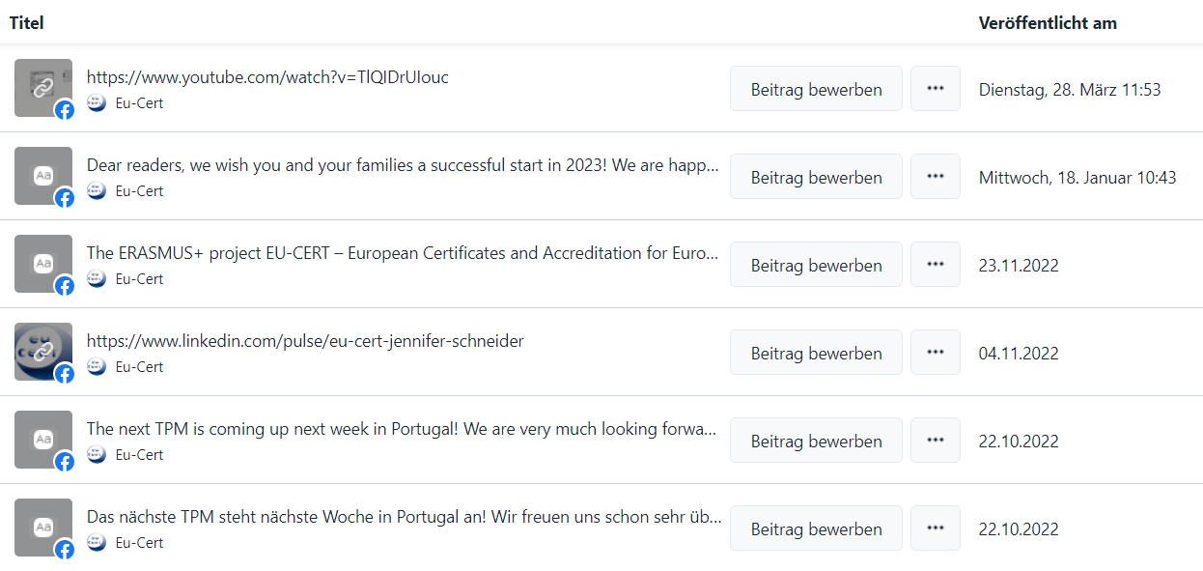
UPB Facebook website of EU-CERT | 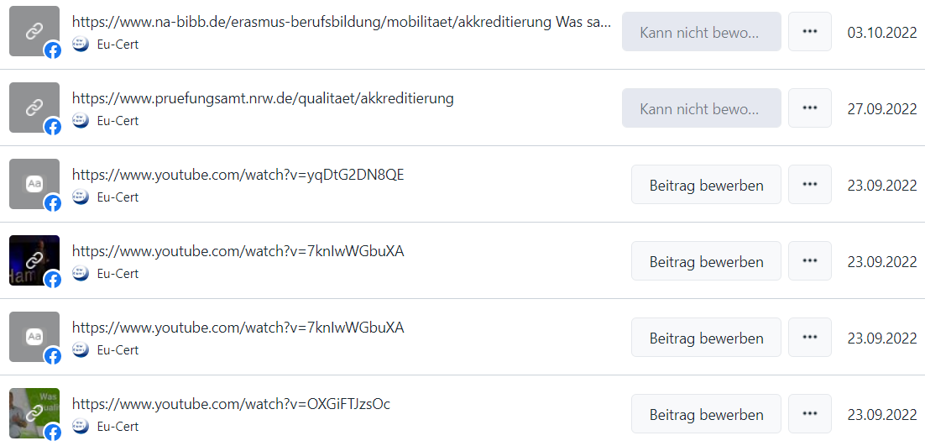
UPB Facebook website of EU-CERT | 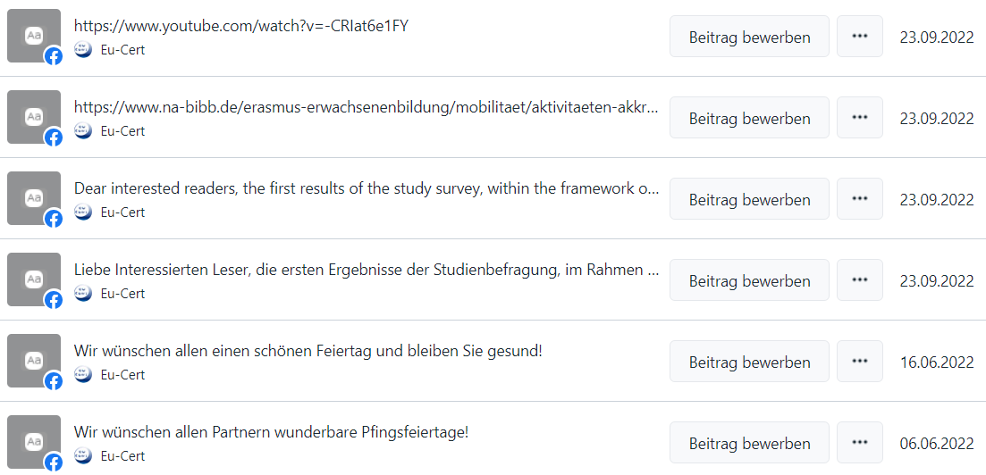
UPB Facebook website of EU-CERT | 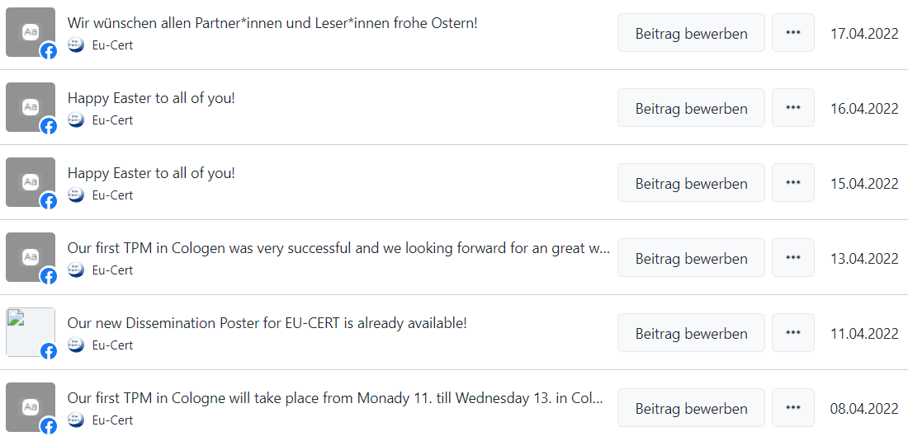
UPB Facebook website of EU-CERT | 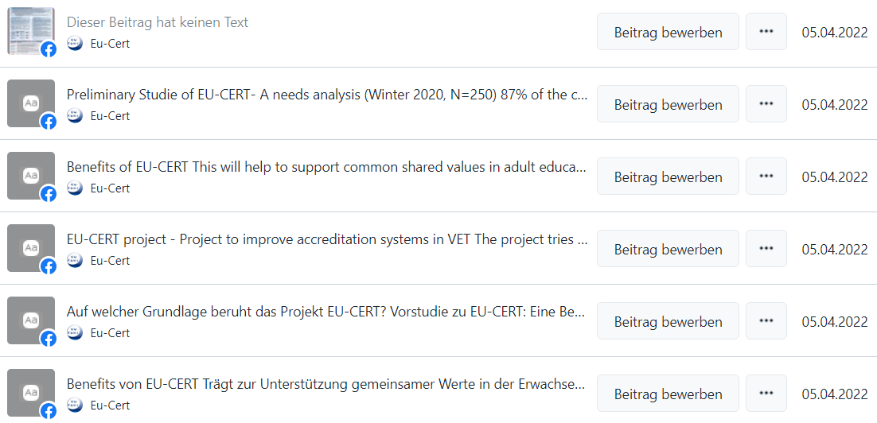
UPB Facebook website of EU-CERT
Other types of online activities/actions:
Titles, short description, names, web-addresses etc. |  |  | Date and Place: |  | Target Group(s): |  |  |  | Numbers Reached: |  |  | Kind of documentation available | Level (L = local; R = regional; N = national; E = EU; O = Outside EU )
E-square project promo |  |  | 01.04.22 |  | All interested readers, teachers, learners and students |  |  |  | Cca 80 |  |  | https://e-square.fr/projects/ | EU
PRINT
Distribution of print material and EU-CERT products at conferences, and meetings, events, etc.
Titles, short description, names, web-addresses etc. |  | Date and Place: |  |  |  | Target Group(s): |  |  | Numbers Reached: |  | Kind of documentation available |  |  | Level (L = local; R = regional; N = national; E = EU; O = Outside EU )
Publishing of EU-CERT info in newsletters, newspapers, magazines, etc.
Titles, short description, names, web-addresses etc. |  | Date and Place: |  |  |  | Target Group(s): |  |  | Numbers Reached: |  | Kind of documentation available |  |  | Level (L = local; R = regional; N = national; E = EU; O = Outside EU )
Publishing of articles in local and international journals
Titles, short description, names, web-addresses etc. |  | Date and Place: |  |  |  | Target Group(s): |  |  | Numbers Reached: |  | Kind of documentation available |  |  | Level (L = local; R = regional; N = national; E = EU; O = Outside EU )
Distribution of info letters and invitations via regular mail
Titles, short description, names, web-addresses etc. |  | Date and Place: |  |  |  | Target Group(s): |  |  | Numbers Reached: |  | Kind of documentation available |  |  | Level (L = local; R = regional; N = national; E = EU; O = Outside EU )
Other print activities/actions:

FACE-TO-FACE
Organised conferences
Titles, short description, names, web-addresses etc. |  | Date and Place: |  |  |  | Target Group(s): |  |  | Numbers Reached: |  | Kind of documentation available |  |  | Level (L = local; R = regional; N = national; E = EU; O = Outside EU )
Organised seminars, workshops, panels, symposia, etc.
Titles, short description, names, web-addresses etc. |  | Date and Place: |  |  |  | Target Group(s): |  |  | Numbers Reached: |  | Kind of documentation available |  |  | Level (L = local; R = regional; N = national; E = EU; O = Outside EU )
Promo of the project on other project KOM |  | 1.5.22 |  |  |  | Other projects’ partners |  |  | 6 |  |  |  |  | EU
Promo of the project on other project LTTA |  | 8.9.22 |  |  |  | Other projects’ partners |  |  | 20 |  |  |  |  | EU
Promo of the project on other project LTTA |  | 23.3.23 |  |  |  | Projects’ stakeholders |  |  | 20 |  |  |  |  | N
Presentations in local and international conferences
Titles, short description, names, web-addresses etc. |  | Date and Place: |  |  |  | Target Group(s): |  |  | Numbers Reached: |  | Kind of documentation available |  |  | Level (L = local; R = regional; N = national; E = EU; O = Outside EU )
Meetings with existing NGO leaders, potential new NGO leaders, local stakeholders, authorities, etc.
Titles, short description, names, web-addresses etc. |  | Date and Place: |  |  |  | Target Group(s): |  |  | Numbers Reached: |  | Kind of documentation available |  |  | Level (L = local; R = regional; N = national; E = EU; O = Outside EU )
Organised exhibitions of EU-CERT material
Titles, short description, names, web-addresses etc. |  | Date and Place: |  |  |  | Target Group(s): |  |  | Numbers Reached: |  | Kind of documentation available |  |  | Level (L = local; R = regional; N = national; E = EU; O = Outside EU )
Utilisation of project products in relevant settings
Titles, short description, names, web-addresses etc. |  | Date and Place: |  |  |  | Target Group(s): |  |  | Numbers Reached: |  | Kind of documentation available |  |  | Level (L = local; R = regional; N = national; E = EU; O = Outside EU )
Demonstrations of project material to stakeholders
Titles, short description, names, web-addresses etc. |  | Date and Place: |  |  |  | Target Group(s): |  |  | Numbers Reached: |  | Kind of documentation available |  |  | Level (L = local; R = regional; N = national; E = EU; O = Outside EU )
Other face-to-face activities/actions:

Other dissemination activities:

