EU-CERT:
European Certificates and Accreditation for European Projects
Project Results 1 - Quantitative Research
TIR Consulting Group j.d.o.o (CROATIA)
March 2022

TIR Consulting Group j.d.o.o
Raj Pathak
Riya Raj

Acronym: EU-CERT
Reference number: 2021-1-DE02-KA220-ADU-000033541
Project duration: 01.02.2022 – 31.05.2024 (28 month)
Proj project partners: University of Paderborn (P0), Coordinator
Ingenious Knowledge GmbH (P1)
RUTIS-Associação Rede de Universidades da Terceira Idade (P2)
TIR Consulting Group j.d.o.o., Kroatien (P3)
Esquare, Frankreich (P4)
STANDO LTD Cyprus (P5)

General Information

This guideline with questions is part of the European project EU-CERT and aims to facilitate the analysis of certification systems and the establishment of quality criteria after the evaluation of the guideline.
The guideline is part of an evaluation as well as analysis and therefore it is important to fill in full sentences and not only some keyword. Please, be so kind and answer as complete as possible and provide examples wherever possible. The guideline comes with open questions in the end where you provide free text, as well as questions where you are asked to do a ranking or rating.
The guideline is used by project partners of the European project EU-CERT. The analysis focusses on the development of a mechanism to monitor the effectiveness of adult education projects. WIth the help of the guideline an accreditation system is developed which is based on clear criteria that are also integrated in the guideline formula and the questions. After the evaluation phase, an accreditation certificate can be elaborated with the help of which adult education can be certified concerning its quality. The certificate can be used as a proof for high or excellent quality of adult education programs.

General instructions for completing the questionnaire:
This guideline consists of a quantitative and qualitative parts and addresses three thematic sections:
- General information
- Estimations and Ratings about adult education programs
- Qualitative open questions on individual views on adult education programs
- Opportunities and Challenges

To handle all questions, you need approximately 20 minutes.
All your information will be analysed and evaluated completely anonymously.
For any further questions, we are at your disposal.
You can reach us and find more important information on our website.

General Information
Gender – I am …

Female | ⚪
Male | ⚪
Rather not say | ⚪
Other / Diverse | ⚪

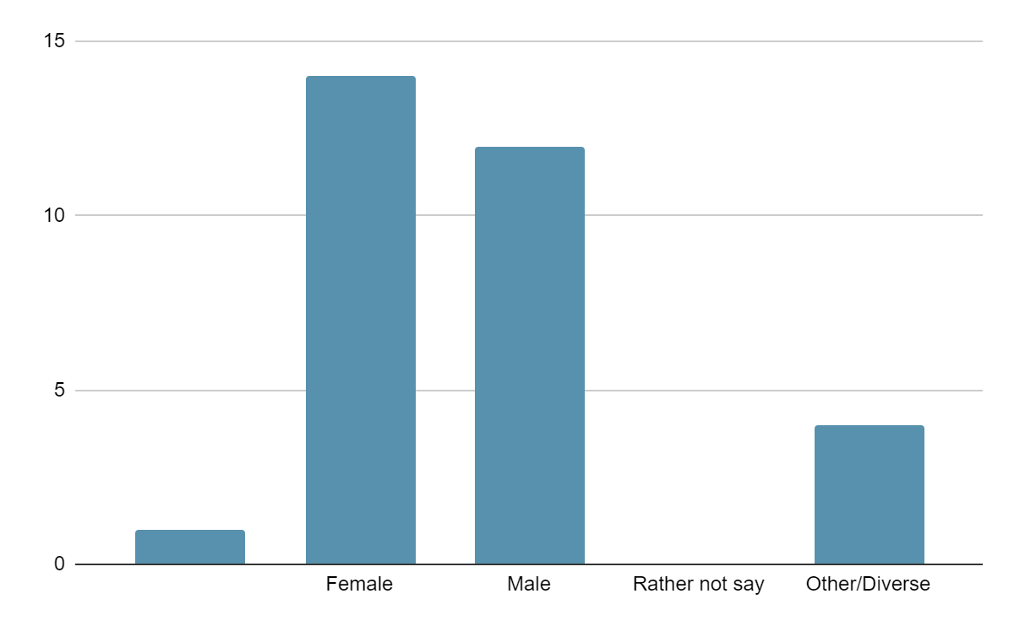

Age

Below 20 | ⚪
21-30 | ⚪
31-40 | ⚪
41-50 | ⚪
51-60 | ⚪
Over 60 | ⚪

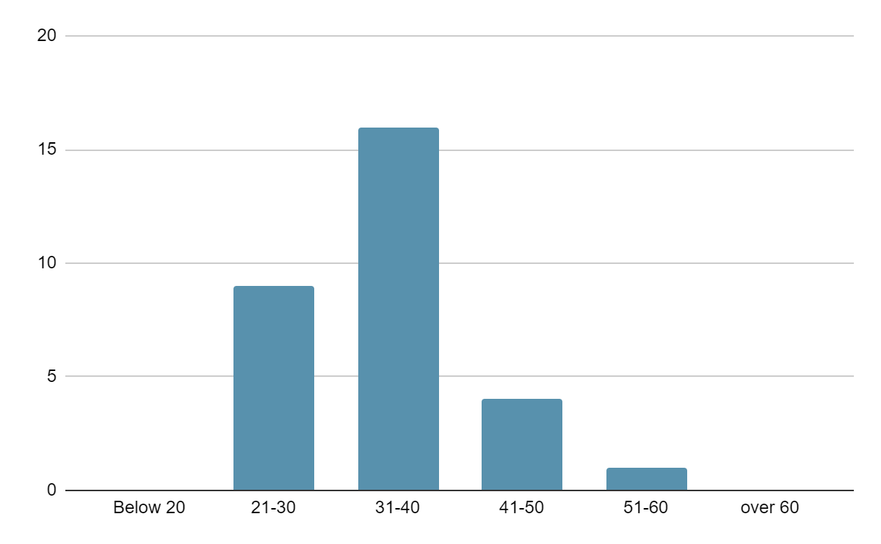

Status – I am …

a trainer/teacher (adult education) | ⚪
a student teacher | ⚪
Other: | ⚪

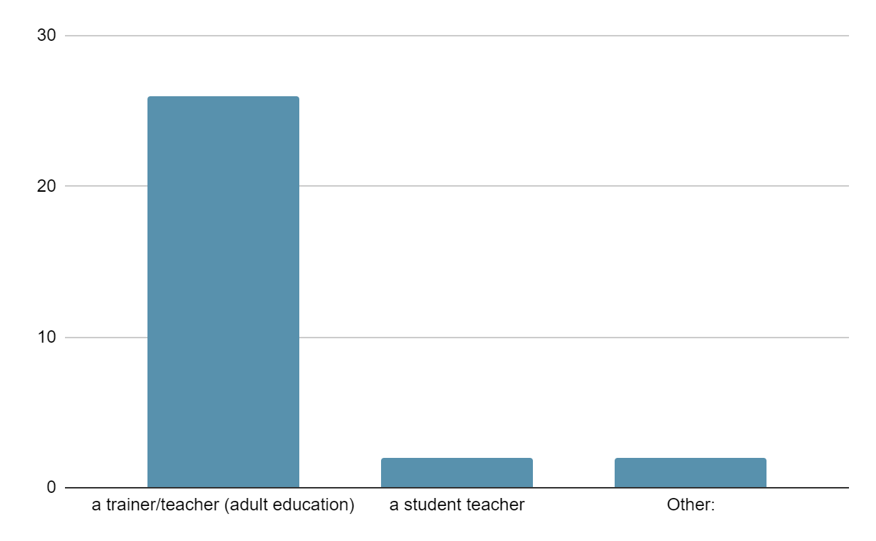

Other (2):
-Project developer
-Project Manager

Status – I am active …

at a secondary school: Gymnasium | ⚪
at a secondary school: Gesamtschule | ⚪
at a secondary school: Realschule | ⚪
at a secondary school: Hauptschule | ⚪
at a vocational school | ⚪
at university as a student teacher | ⚪
Other | ⚪

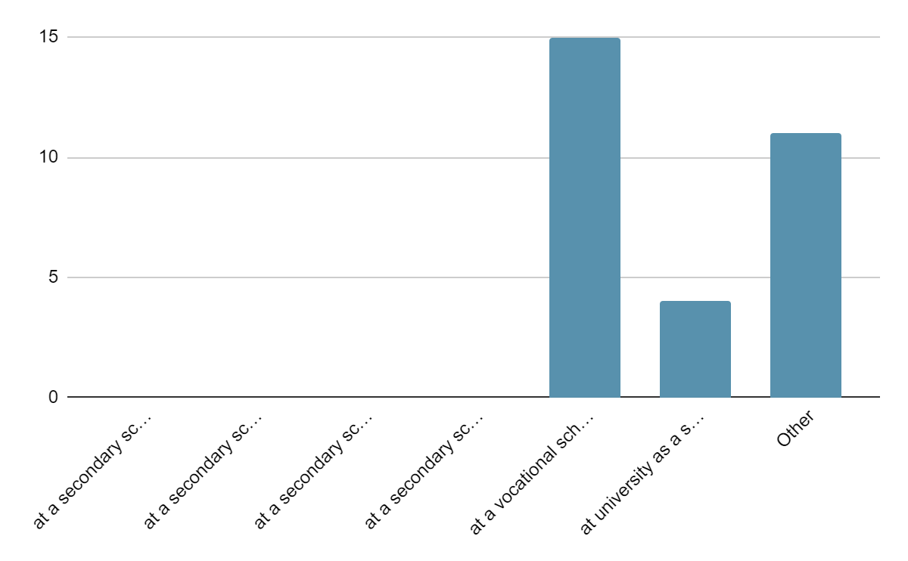

Others:
-Adult Education trainers in NGOs/SMEs/Social Entreprises (11)

Estimations and ratings about adult education programs
In how far are the following criteria integrated in the adult education program [AEP]? (please make a first mark with a cross in each line)
Are the criteria of a specific relevance for the adult education program? (please make a second mark with a cross in each line)

 | first mark  with a cross |  |  | second mark  with a cross
 | The criteria is completely integrated in the EAP | The criteria is partly integrated in the EAP | The criteria is not integrated in the EAP | The criteria is of specific relevance for the EAP | The criteria is not of specific relevance for the EAP
Effective strategies for enhancing basic skills | ⚪ | ⚪ | ⚪ | ⚪ | ⚪
Development of basic and transversal skills by using innovative methods | ⚪ | ⚪ | ⚪ | ⚪ | ⚪
High competence of the adult educator | ⚪ | ⚪ | ⚪ | ⚪ | ⚪
Contribution to the development of a European area of skills and qualifications | ⚪ | ⚪ | ⚪ | ⚪ | ⚪
Inclusive approaches of adult education programs | ⚪ | ⚪ | ⚪ | ⚪ | ⚪
Support of general European values and shared values of democracy | ⚪ | ⚪ | ⚪ | ⚪ | ⚪

FIRST MARK

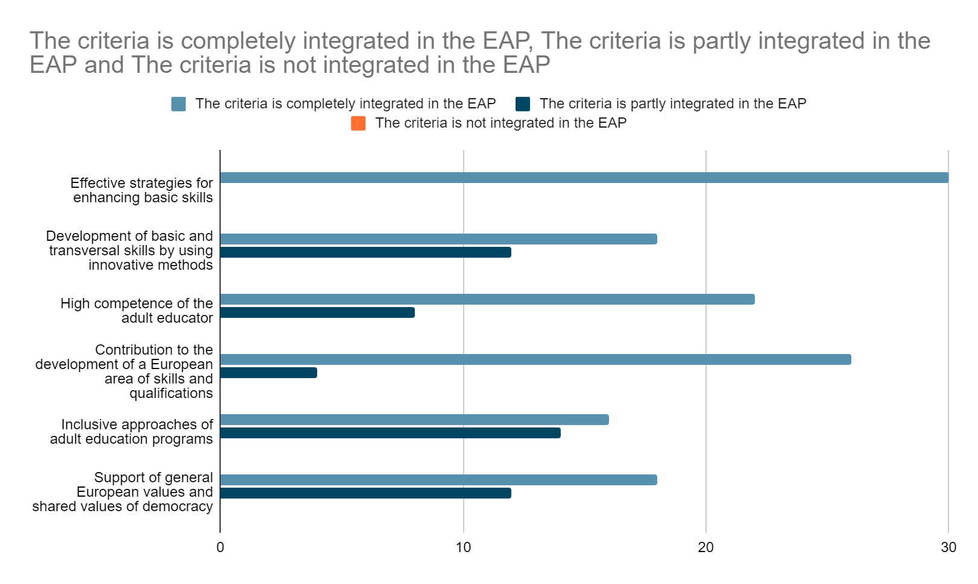

SECOND MARK
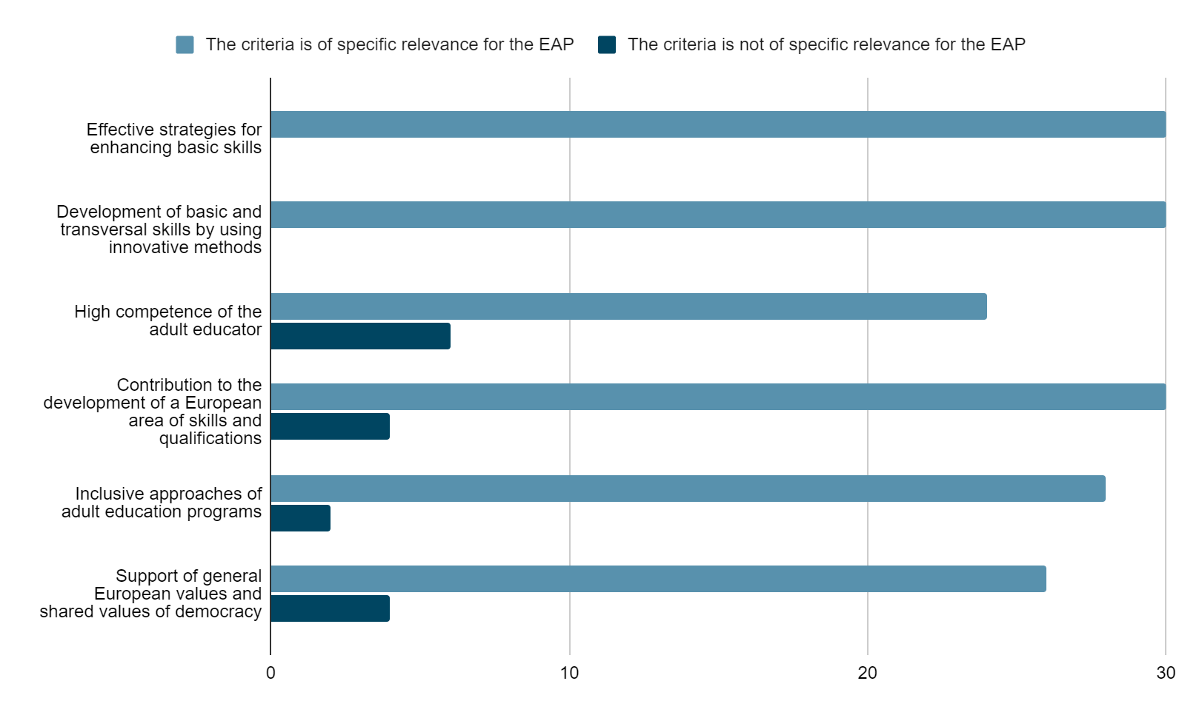

How important is the content of the AEP against the background of the necessity of raising international awareness also in terms of EU-Citizenships?
Rate with one cross on a scale from 1 to 10 (1 – unimportant to 10 – important)

1 | 2 | 3 | 4 | 5 | 6 | 7 | 8 | 9 | 10
⚪ | ⚪ | ⚪ | ⚪ | ⚪ | ⚪ | ⚪ | ⚪ | ⚪ | ⚪

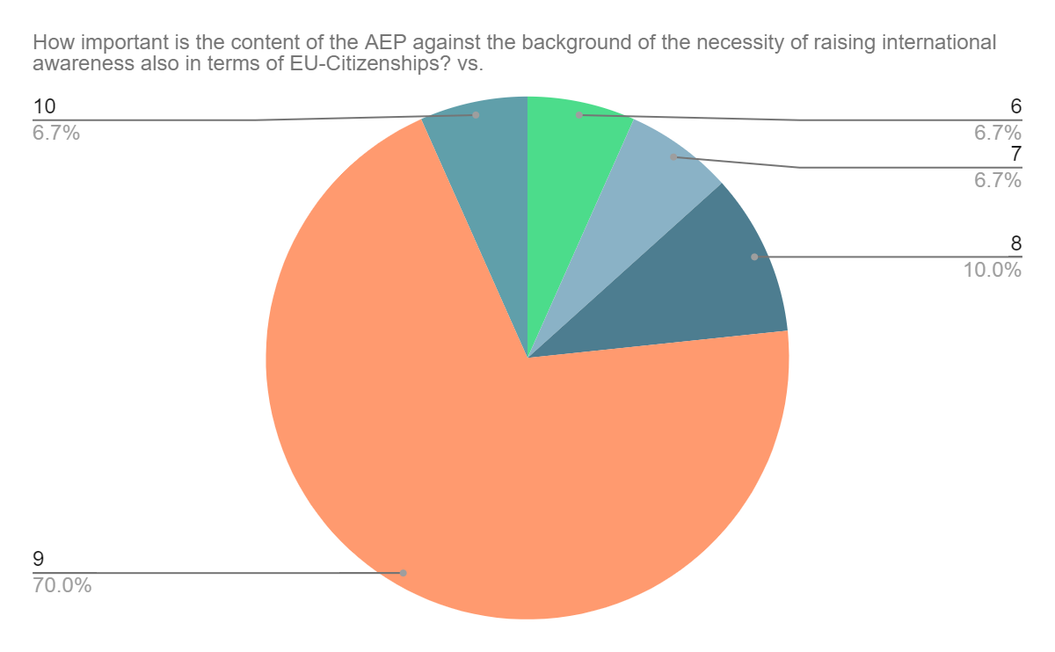

How important will the content of the AEP be in five years concerning the current social, political as well as economic developments?
Rate with one cross on a scale from 1 to 10 (1 – unimportant to 10 – important)

1 | 2 | 3 | 4 | 5 | 6 | 7 | 8 | 9 | 10
⚪ | ⚪ | ⚪ | ⚪ | ⚪ | ⚪ | ⚪ | ⚪ | ⚪ | ⚪

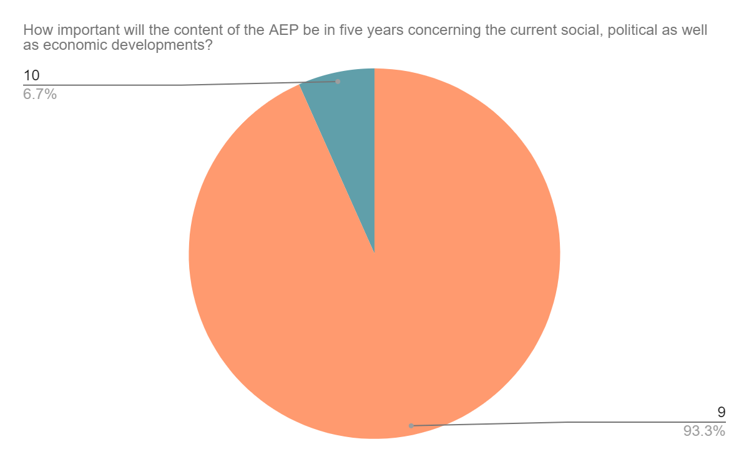

In how far does the AEP focus on the enhancement of digital teaching and learning also in terms of the strengthening of education and training paths of educators and youth workers? (Please, make one cross in each line.)

 | strongly  represented | represented | rather rejected | strongly rejected
The educators work with digital media during the AEP sessions | ⚪ | ⚪ | ⚪ | ⚪
The AEP is part of a learning platform and is absolved by the participants in a digital way | ⚪ | ⚪ | ⚪ | ⚪
The communication between educators and participants is of intersocial as well as digital nature | ⚪ | ⚪ | ⚪ | ⚪
The participants learn about the use of digital media and its efficient application in their specific field of interest | ⚪ | ⚪ | ⚪ | ⚪
The educator is able to help the participants with problems concerning digital work and use of digital media | ⚪ | ⚪ | ⚪ | ⚪
The participants can acquire different ways of working digitally by experiencing digital work as presented methods during the AEP | ⚪ | ⚪ | ⚪ | ⚪
The participants strengthen their digital competences as important soft skills in their work environment | ⚪ | ⚪ | ⚪ | ⚪

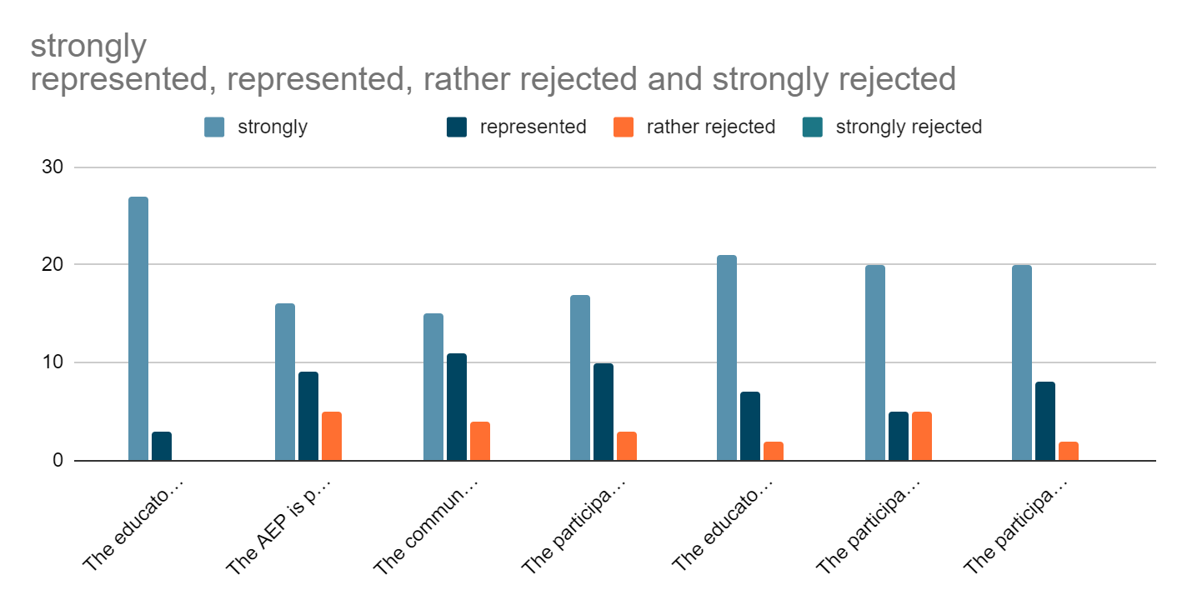

How important are the following aspects of AEPs concerning their individual quality?
In general the AEP focuses on the importance of the quality criteria of … (Please, make one cross in each line.)

 | very  important | important | less important | unimportant
… the increasement of the efficiency of public expenditure and the appropriate investments in education, training and youth work by dealing with urgent social, political or educational issues | ⚪ | ⚪ | ⚪ | ⚪
… presenting high quality learning opportunities by training participants in their basic skills, adapting the new acquired knowledge to the work-life and the necessities and demands in the individual work spheres of the participants | ⚪ | ⚪ | ⚪ | ⚪
… the promotion of entrepreneurship education and social entrepreneurship among the participants by deepening their insights and competences also in terms of entrepreneurship as a benefit for their individual work-life | ⚪ | ⚪ | ⚪ | ⚪
… the strengthening of quality by providing mobility as well as cross-border ad international cooperations in which the participants can take part | ⚪ | ⚪ | ⚪ | ⚪
… the open examination of foreign cultures and dealing with cultural differences and similarities by focusing on EU-citizenship and international shared values and identities | ⚪ | ⚪ | ⚪ | ⚪
Other aspects, please specify: ____________ | ⚪ | ⚪ | ⚪ | ⚪

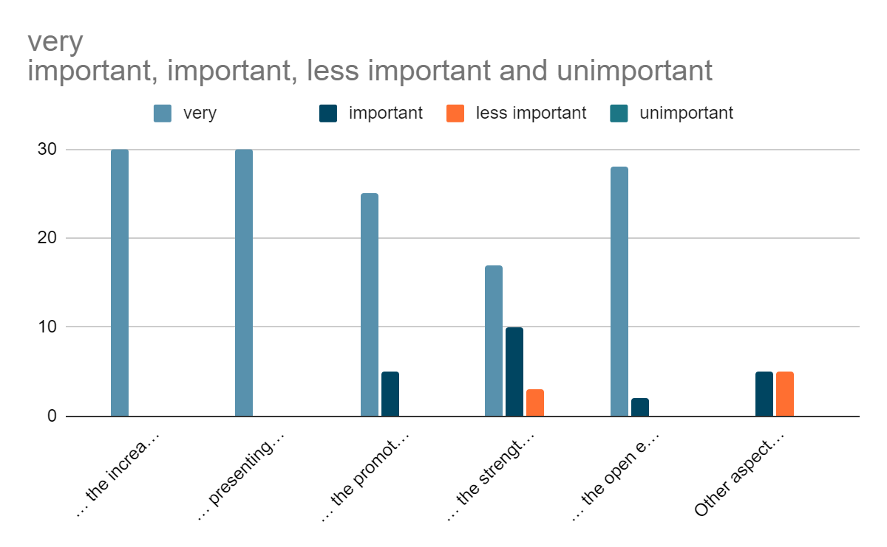

Present a tendency!
The AEP focuses on … (Please, make one cross in each line.)

international content | ⚪ | ⚪ | ⚪ | ⚪ | ⚪ | ⚪ | regional content
digital communication | ⚪ | ⚪ | ⚪ | ⚪ | ⚪ | ⚪ | face-to-face interaction
cooperation with international enterprises | ⚪ | ⚪ | ⚪ | ⚪ | ⚪ | ⚪ | independent courses and programs
active participation in international exchange | ⚪ | ⚪ | ⚪ | ⚪ | ⚪ | ⚪ | the demands in the regional work-life of the participants
innovative teaching methods | ⚪ | ⚪ | ⚪ | ⚪ | ⚪ | ⚪ | classic teaching methods
specifically trained educators | ⚪ | ⚪ | ⚪ | ⚪ | ⚪ | ⚪ | broader trained educators which tutor each a variety of different courses and programs
useful extension of the participants individual soft skills for their individual working sphere | ⚪ | ⚪ | ⚪ | ⚪ | ⚪ | ⚪ | extension of a broader variety of skills of the participants
easy application of the course issues in the participants work life | ⚪ | ⚪ | ⚪ | ⚪ | ⚪ | ⚪ | general improvement of individual skills independent of demands at work

international content | ⚪ | ⚪ | ⚪ | ⚪ | ⚪ | ⚪ | regional content

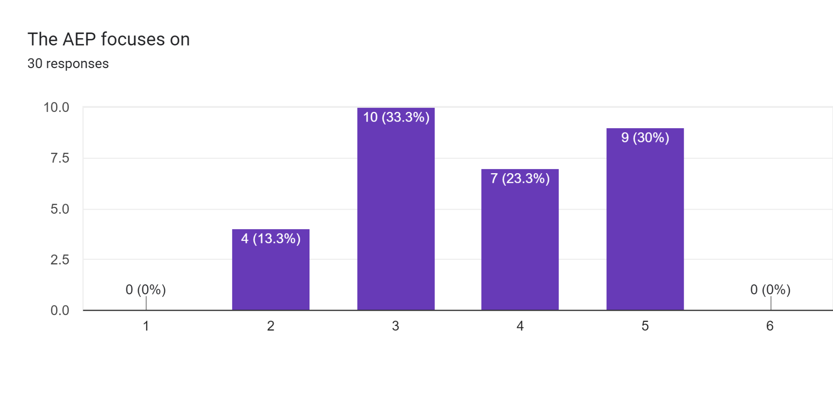

digital communication | ⚪ | ⚪ | ⚪ | ⚪ | ⚪ | ⚪ | face-to-face interaction

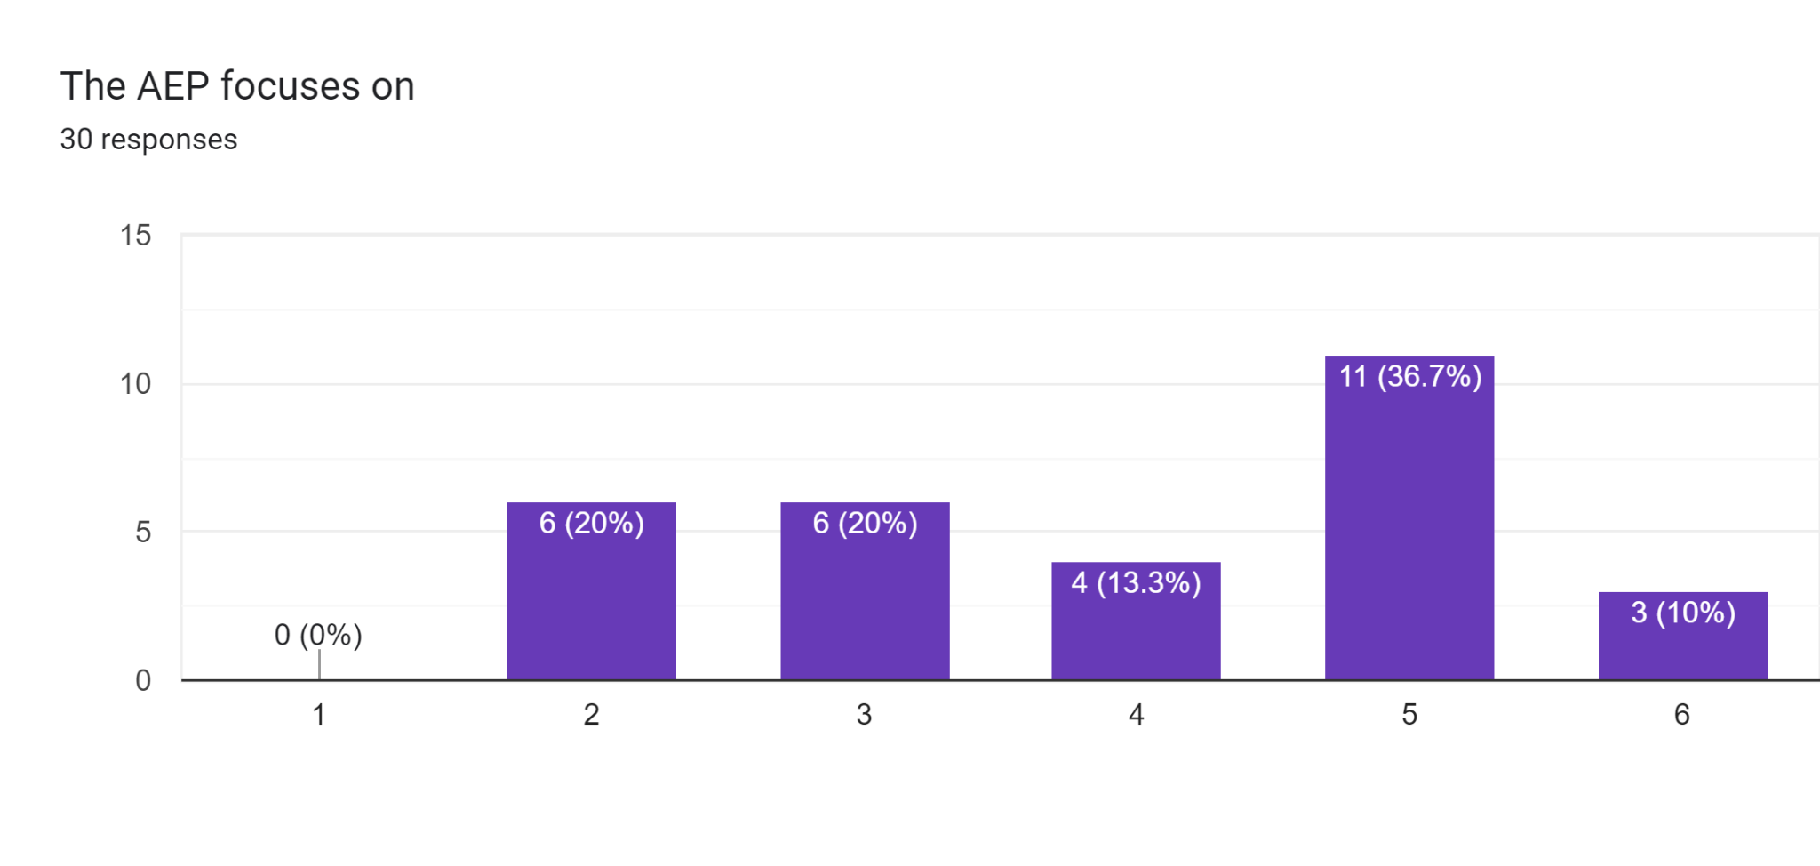

cooperation with international enterprises | ⚪ | ⚪ | ⚪ | ⚪ | ⚪ | ⚪ | independent courses and programs

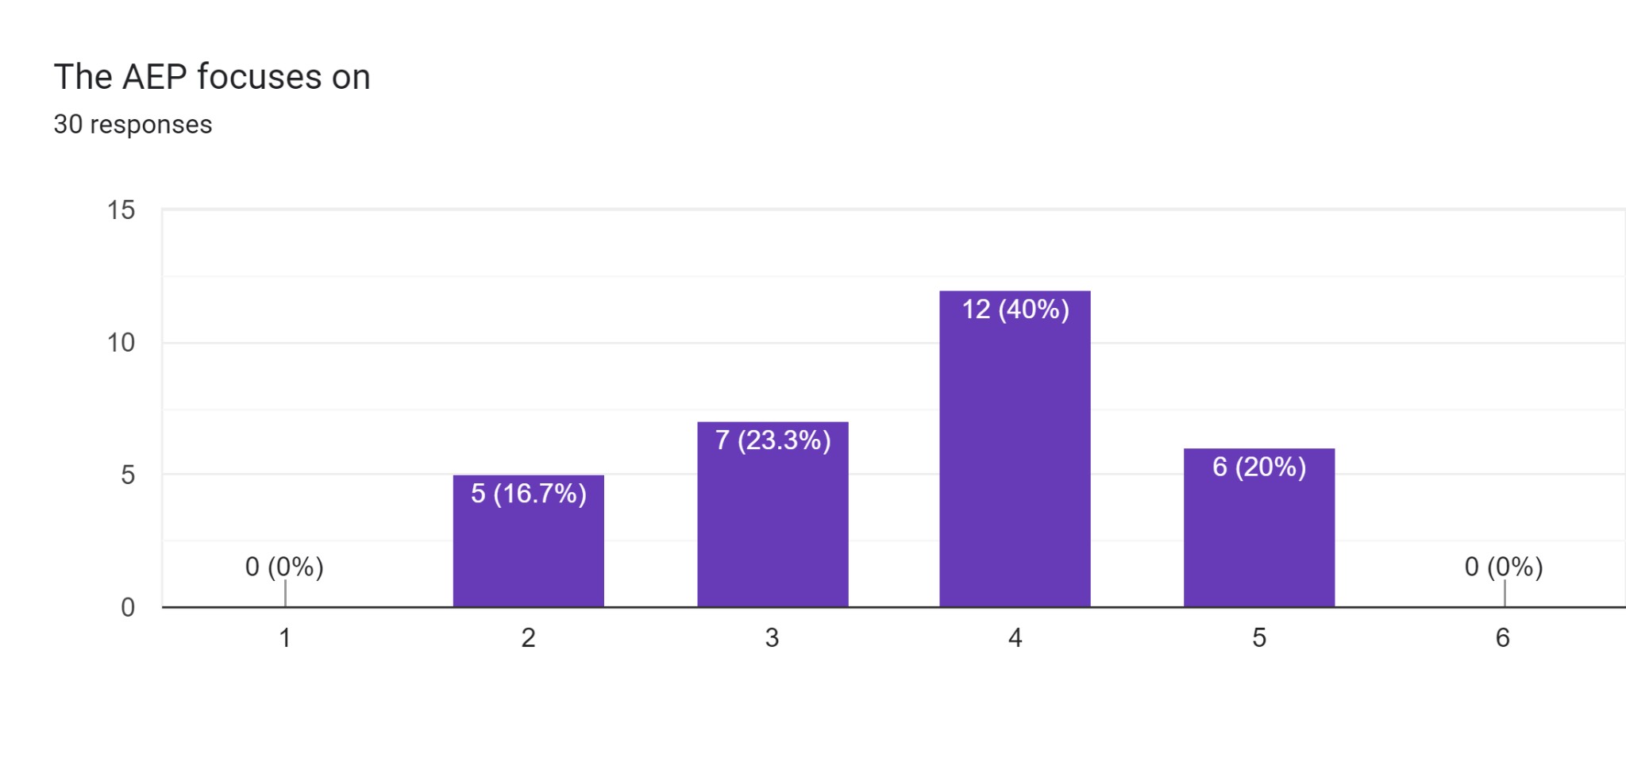

active participation in international exchange | ⚪ | ⚪ | ⚪ | ⚪ | ⚪ | ⚪ | the demands in the regional work-life of the participants

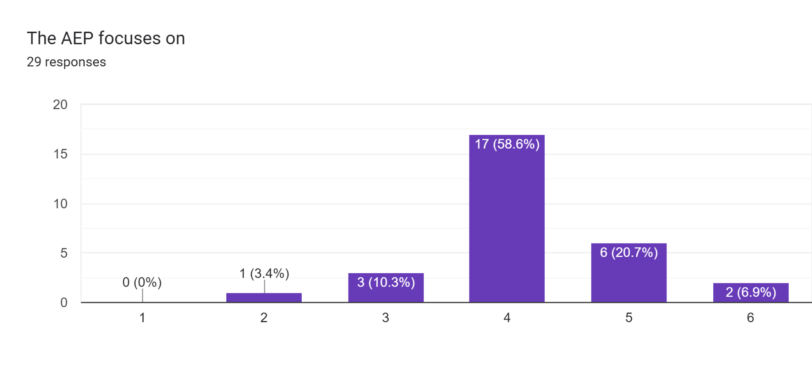

innovative teaching methods | ⚪ | ⚪ | ⚪ | ⚪ | ⚪ | ⚪ | classic teaching methods

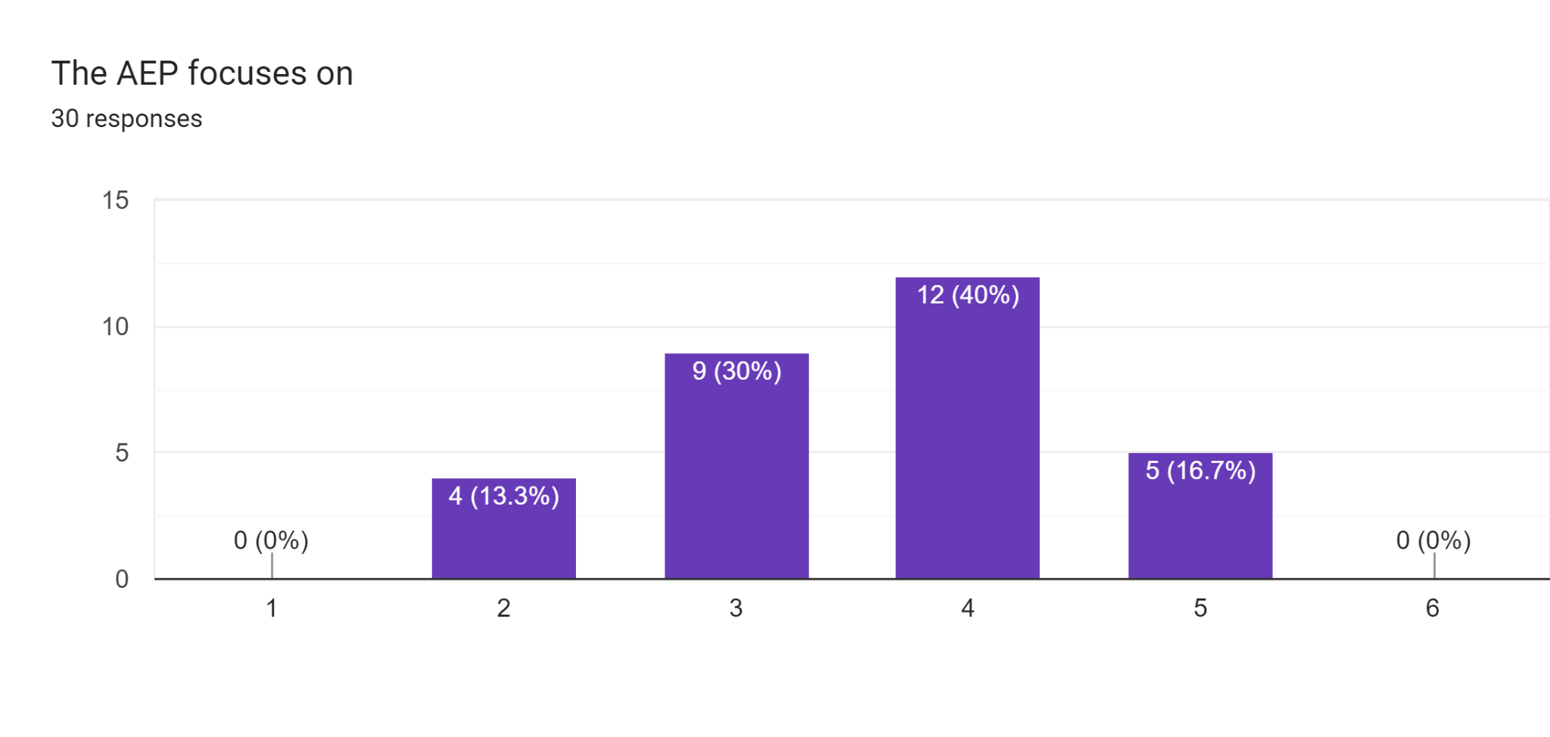

specifically trained educators | ⚪ | ⚪ | ⚪ | ⚪ | ⚪ | ⚪ | broader trained educators which tutor each a variety of different courses and programs
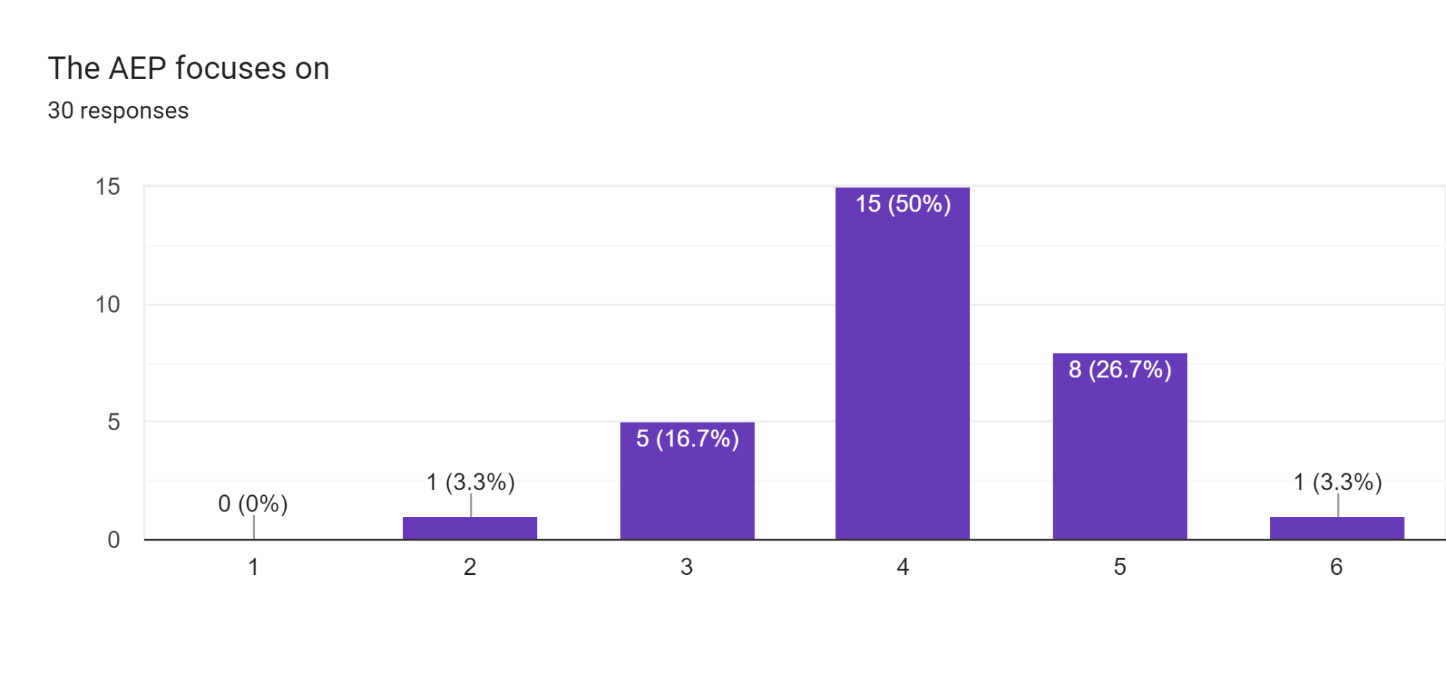

useful extension of the participants individual soft skills for their individual working sphere | ⚪ | ⚪ | ⚪ | ⚪ | ⚪ | ⚪ | extension of a broader variety of skills of the participants

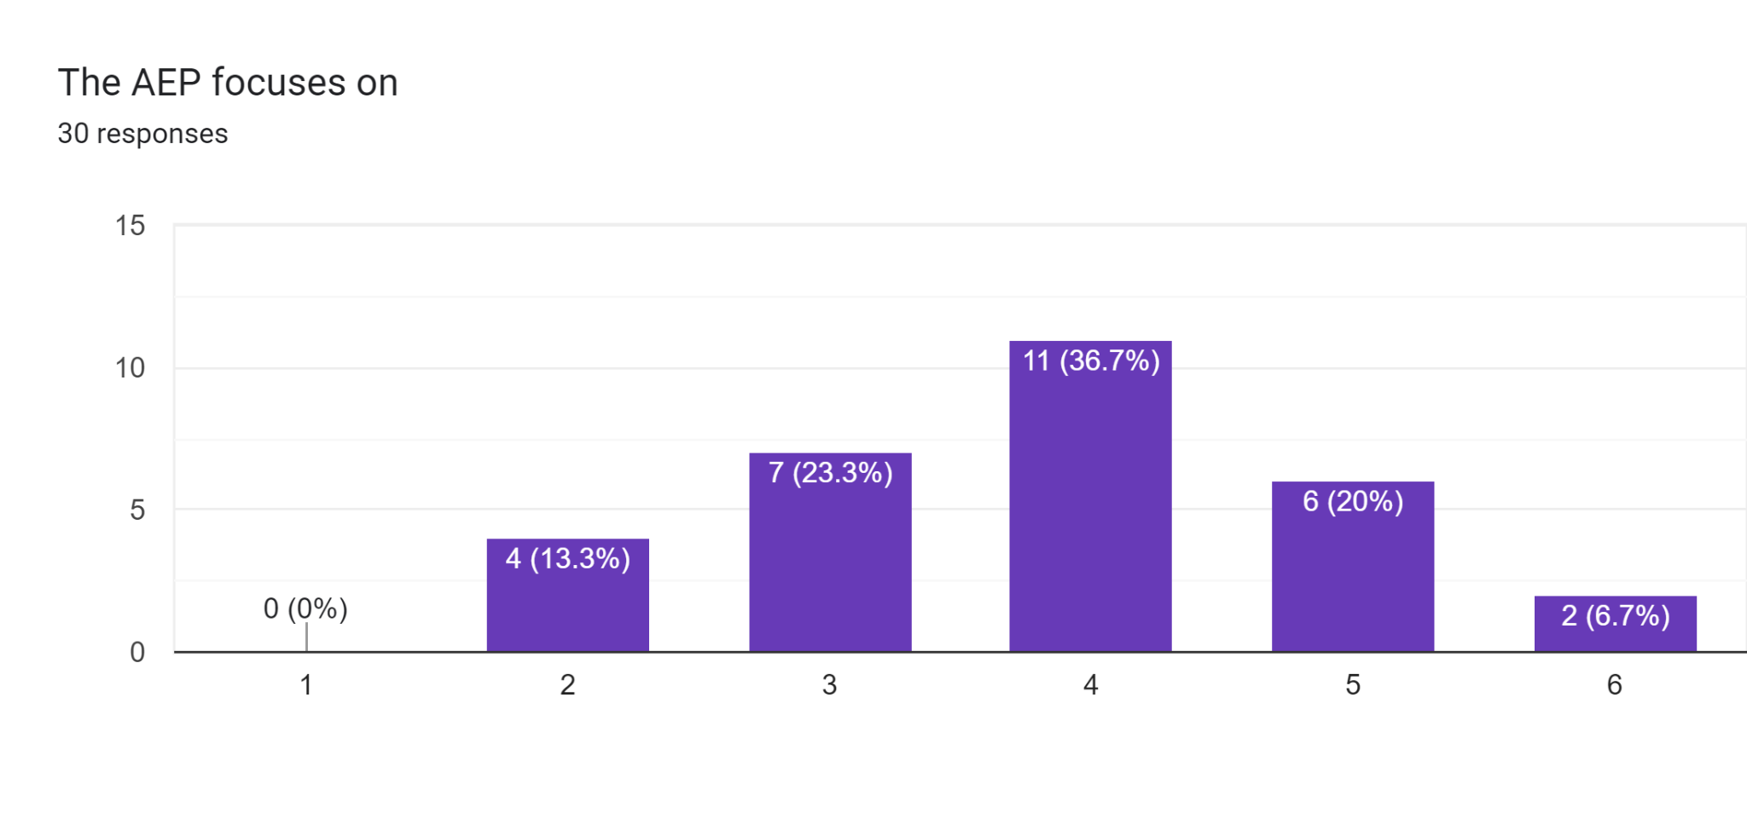

specifically trained educators | ⚪ | ⚪ | ⚪ | ⚪ | ⚪ | ⚪ | broader trained educators which tutor each a variety of different courses and programs

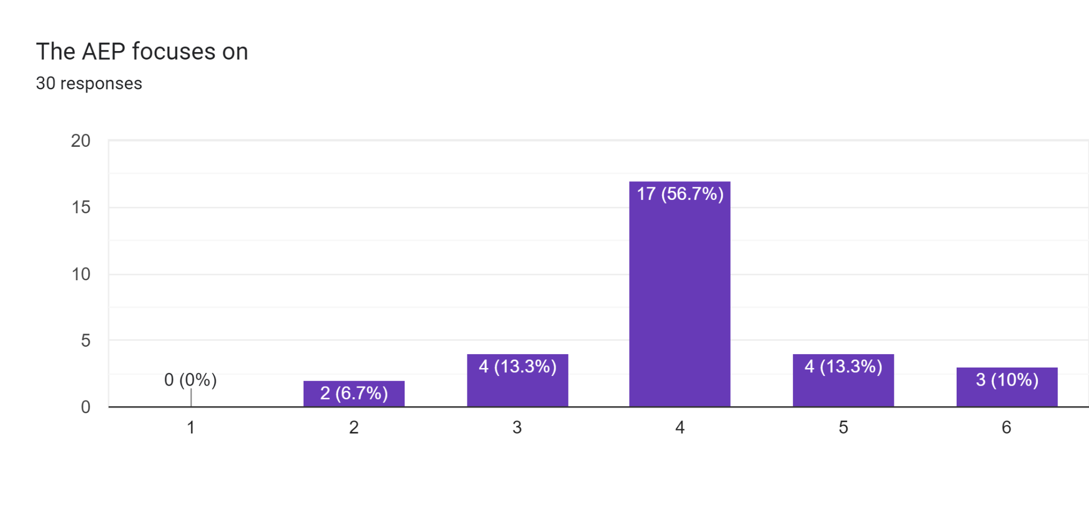

Qualitative open questions on your individual use of teaching methods

In how far are disparities in learning outcomes, which especially affect disadvantaged learners, reduced during the learning process in the AEP? (Please, write about half a page)

The adult education sector in Croatia plays a vital role in reducing disparities in learning outcomes, particularly for disadvantaged learners. The sector offers a range of programs and courses that are designed to meet the diverse needs of adult learners from all backgrounds, including those who may face social, economic, or educational barriers to learning.
One way in which adult education programs help to reduce disparities in learning outcomes is by providing tailored support to learners who need it most. Many programs offer individualized learning plans, tutoring, and mentorship to help learners overcome obstacles and achieve their goals. This can be especially important for disadvantaged learners who may have missed out on educational opportunities earlier in life, or who may be dealing with other challenges that make learning difficult.
Additionally, adult education programs often use innovative and flexible teaching methods that can help to engage learners who may struggle with traditional classroom-based instruction. For example, programs may use technology to deliver courses online, offer interactive learning activities, or use experiential learning methods to help learners apply their new knowledge and skills in real-world situations. These approaches can be particularly effective for learners who may have different learning styles or who may face barriers to attending traditional classroom-based courses.
Finally, adult education programs can also help to reduce disparities in learning outcomes by providing learners with a range of support services that address their broader needs. For example, many programs offer career counseling, job placement services, or financial assistance to help learners overcome economic barriers to learning. Others may offer health and wellness services or provide access to community resources that can help learners address social or personal challenges that may affect their learning.

In how far does the AEP contribute to the European Union in terms of the empowerment of a shared internation European identity and participation in international affairs? (Please, write about half a page)

The Adult Education Projects (AEP) in Croatia contribute significantly to the European Union (EU) in terms of empowering a shared international European identity and promoting participation in international affairs. Adult education plays a vital role in promoting social inclusion, active citizenship, and lifelong learning, which are key pillars of the EU's vision for a democratic and cohesive Europe.
One way in which the AEP contributes to the EU's vision is by promoting a shared European identity. Through education and training, adult learners are exposed to diverse cultures, languages, and perspectives, which can help to foster a sense of belonging to a larger European community. This can be particularly important in Croatia, which has a unique history and culture that is intertwined with its European identity. The AEP helps to promote this shared identity by offering courses and programs that focus on European history, culture, and politics, as well as providing opportunities for learners to engage with their European counterparts through study visits, exchanges, and international projects.
Furthermore, the AEP promotes participation in international affairs by preparing learners to engage in a globalized world. Through education and training, learners develop the knowledge, skills, and competencies needed to participate actively in international affairs, including intercultural communication, problem-solving, and critical thinking. Additionally, adult education programs often offer language courses, which enable learners to communicate effectively across borders and participate in international organizations and networks.
The AEP also contributes to the EU's efforts to promote social and economic development, which are central to its broader foreign policy objectives. Through adult education, learners are equipped with the skills and knowledge needed to address social and economic challenges, such as poverty, inequality, and unemployment. This, in turn, can contribute to the EU's broader efforts to promote sustainable development, reduce social exclusion, and build resilient communities.

How close does the AEP cooperated with (international) enterprises to ensure the close connection to the work-life of the participants? (Please, write about half a page)

The adult education sector in Croatia has recognized the importance of cooperating with enterprises and businesses to ensure a close connection between adult education projects and the work-life of participants. Through collaboration with international and local enterprises, adult education projects are better able to align their programs with the needs of the labor market, ensuring that learners are equipped with the skills and knowledge needed to succeed in the workforce.
One way in which the AEP cooperates with enterprises is through the development of customized training programs. These programs are designed in collaboration with employers and are tailored to the specific needs of the organization. By working closely with employers, adult education providers can ensure that their programs are aligned with the skills and knowledge that are in high demand in the labor market, and that learners are well-equipped to meet the needs of employers.
Furthermore, adult education providers also offer various internships, apprenticeships, and work-based learning opportunities, which allow learners to gain hands-on experience in a real work environment. These programs are designed in collaboration with enterprises, and they provide learners with the opportunity to apply their knowledge and skills in a practical setting. This can be particularly beneficial for learners who are looking to make a career change or who may be new to the workforce.
In addition, adult education providers also work closely with employers to ensure that learners have access to job placement services and career development opportunities. By collaborating with enterprises, adult education providers can help to bridge the gap between education and the labor market, ensuring that learners are well-prepared to enter and succeed in the workforce.
In summary, the adult education sector in Croatia recognizes the importance of collaborating with enterprises to ensure a close connection between adult education projects and the work-life of participants. Through customized training programs, internships, apprenticeships, work-based learning, and job placement services, adult education providers can ensure that learners are well-equipped to meet the needs of employers and succeed in the workforce. This collaboration is essential for promoting economic growth and social inclusion, and it is a key priority for the adult education sector in Croatia.

Is the European orientation and allignement of the AEP visible in some way as European funding, European partnership or promotion of European values and citizenship? (Please, write about half a page)

Yes, the European orientation and alignment of the AEP is visible in several ways, including through the support of European funding, partnerships with European organizations, and the promotion of European values and citizenship.
Firstly, European funding plays a significant role in supporting adult education projects in Croatia. Funding is often provided by the European Union through various programs such as the Erasmus+ program, which supports transnational learning and mobility for adult learners, and the European Social Fund, which aims to promote social inclusion and combat poverty. These funding programs are designed to support projects that align with the values and priorities of the European Union, such as promoting lifelong learning, improving employability, and fostering social cohesion.
Secondly, partnerships with European organizations are also a key aspect of the European alignment of the AEP. Adult education providers in Croatia often collaborate with European organizations, such as the European Association for the Education of Adults (EAEA), to exchange knowledge and best practices, promote policy dialogue, and engage in advocacy activities. These partnerships help to ensure that adult education projects in Croatia are aligned with European priorities and values.
Finally, the promotion of European values and citizenship is also a key objective of the AEP in Croatia. Adult education providers aim to promote values such as democracy, human rights, and tolerance, and to encourage active citizenship and participation in civil society. These values are in line with the priorities of the European Union and are central to the European project of promoting social cohesion and inclusion.

Opportunities and Challenges

What are the opportunities of the specific AEP?
(Please, write at least 6 lines.)

The specific AEP (Adult Education Projects) in Croatia offers several opportunities for learners, educators, and the wider community. Firstly, it provides opportunities for adults to acquire new knowledge, skills, and competencies, which can improve their employability and enhance their personal and professional development. Secondly, AEPs can facilitate the integration of disadvantaged groups into society, such as migrants, refugees, and the elderly, by providing targeted and tailored learning opportunities. Thirdly, AEPs can support social cohesion and community development by bringing people together and promoting dialogue and mutual understanding. Fourthly, AEPs can provide opportunities for educators and trainers to develop their professional skills and expertise, through training, networking, and collaboration. Fifthly, AEPs can contribute to the wider policy objectives of the European Union, such as promoting lifelong learning, social inclusion, and active citizenship. Finally, AEPs can promote innovation and creativity, by encouraging experimentation with new pedagogies, technologies, and learning environments. Overall, the specific AEP in Croatia presents a range of opportunities for individuals and society, which can contribute to personal, social, and economic development.

What are the challenges of the specific AEP?
(Please, write at least 6 lines.)

The specific AEP (Adult Education Projects) in Croatia faces several challenges that can impact the effectiveness and sustainability of adult education initiatives. Firstly, there is a lack of funding for adult education projects, which can limit the scale and reach of programs and lead to inequalities in access to learning opportunities. Secondly, there is a shortage of qualified and experienced adult educators and trainers, which can affect the quality of learning outcomes and limit the diversity of learning approaches. Thirdly, there is a need for greater recognition and validation of non-formal and informal learning, which can inhibit the integration of adult learners into the labor market and wider society. Fourthly, there is a challenge in reaching and engaging with disadvantaged groups, who may face barriers such as language, literacy, and social isolation. Fifthly, there is a need for greater coordination and cooperation between different stakeholders in the adult education ecosystem, such as policy-makers, education providers, employers, and civil society organizations. Finally, there is a need for greater innovation and experimentation in adult education, to respond to changing social, economic, and technological trends. Overall, the specific AEP in Croatia faces several challenges that require a coordinated and collaborative effort to address, in order to promote inclusive and effective adult education programs.

What are the most striking quality critieria of the specific AEP [e.g. international or European orientation, digital work, connection to work-life, promotion and extension of soft skills…]
(Please, write at least 6 lines.)

The specific AEP (Adult Education Projects) in Croatia demonstrates several quality criteria that contribute to its effectiveness and impact. Firstly, there is a strong emphasis on promoting international and European orientation, by fostering partnerships with European institutions and organizations, and promoting the values of European citizenship and democracy. Secondly, there is a commitment to embracing digital technologies, to enhance the accessibility and flexibility of learning opportunities, and to promote digital literacy skills among learners and educators. Thirdly, there is a focus on connecting the learning process to the work-life of participants, by providing relevant and practical training that is aligned with the needs of the labor market. Fourthly, there is a recognition of the importance of promoting and extending soft skills, such as communication, teamwork, and problem-solving, which are essential for personal and professional development. Fifthly, there is an emphasis on promoting inclusion and social justice, by targeting disadvantaged groups and promoting diversity and equality in the learning process. Finally, there is a commitment to promoting innovation and experimentation, by encouraging new pedagogies, methodologies, and approaches, which can respond to emerging trends and challenges in adult education. Overall, the specific AEP in Croatia demonstrates several quality criteria that reflect a commitment to excellence and effectiveness in adult education.

Do you want to provide other comments on the topic?

