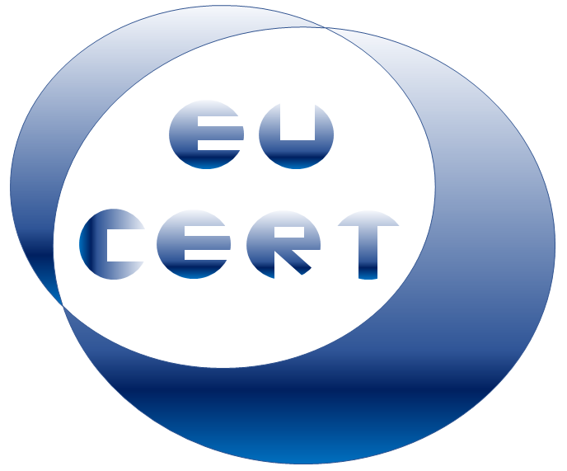

**EU-CERT**

***European Certificates and Accreditation for European Projects***

**Agenda for the fourth EU-CERT transnational partner meeting  
in Zagreb, Croatia**

**The EU-CERT – Accreditation and Documentation Conference!**

**5th - 7th of December 2023**

**Project Title:** European Certificates and Accreditation for European Projects

**Acronym:** EU-CERT

**Reference number:** 2021-1-DE02-KA220-ADU-000033541   
**Project partners:**

P1 University Paderborn (UPB), DE  
 P2 Ingenious Knowledge GmbH (IK), DE  
 P3 Associação Rede de Universidades da Terceira Idade (RUTIS), PT  
 P4 TIR Consulting Group j.d.o.o., (TIR), CR  
 P5 Esquare (ESQ), FR  
 P6 STANDO Ltd. (STANDO), CY

**Host:** TIR Consulting Group, Croatia

**Venue:** *InstantOffice d.o.o. 5th Floor PALM Room Zagrebtower, Radnička cesta 80 HR - 10000 Zagreb*

**Tuesday, 5th of December 2023 –  
Arrival day**

|  |  |  |
| --- | --- | --- |
| Approx. Time | Topic | Chair |
| *as you like* | *Arrival at the hotels in Zagreb* |  |

**Wednesday, 6th of December 2023 –  
Meeting day**

|  |  |  |
| --- | --- | --- |
| Approx. Time | Topic | Chair |
| 09:45 – 10:00 | **Welcoming the EU-CERT partners** *(Rajesh Pathak / Marc Beutner)*   * Warm welcome * Schedule of the meeting | TIR */  UPB /  All partners* |
| 10:00 – 10:30 | **Current Status of the EU-CERT project** *(Marc Beutner)*   * Rationale, purpose, core ideas and aims of the project * Overview of the project results and linkages * Project website, Discussion, and Q&A | *UPB* |
| 10:30 – 11.30 | **Current Status of the EU-CERT project in the partner countries / at the partner organisations – Dissemination and integration**   * 5 Minute PowerPoint presentation: Every partner presents the activities at the own institution in a max. 5 minutes * Discussion | *All* |
| 11:30 – 12.30 | **Insight into PR2 and PR3: EU-CERT – Accreditation Website and Accreditation Process** *(Marc Beutner / Helene Lindenthal / Rasmus Pechuel)*   * PR-Overview * Tasks | *UPB / IK* |

|  |  |  |
| --- | --- | --- |
| Approx. Time | Topic | Chair |
| 12:30 – 13:30 | *Lunch*  ***details will be finalized after numbers known plus dietary requirements if any*** |  |
| 13:30 – 14:15 | **Insight into PR5: EU-CERT – Roll-out of the Accreditation process**  *(Marc Beutner / Soňa Štefková)*   * PR-Overview * Tasks | *UPB / ESQ* |
| 14:15 – 14:45 | **Discussion on the roll-out process** *(Marc Beutner)* | *All partners* |
| 14:45 – 15:30 | **Insight into PR4: EU-CERT - Accreditation Handbook** *(Marc Beutner / Helene Lindenthal)*   * PR-Overview * Tasks | *UPB* |
| 15:30-15:45 | **Insight into PR6 / PR7: EU-CERT - Policy Paper and Layman´s Report** *(Luis Jacob / Rajesh Pathak)*   * PR-Overview * Tasks | *RUTIS / TIR* |
| 15:45 – 16:30 | **Administrative and Financial Information** *(Rasmus Pechuel / Marc Beutner)*   * Project management structure * Documentary evidence required * Online finance and project management tool (PROM) | *IK/UPB* |

|  |  |  |
| --- | --- | --- |
| Approx. Time | Topic | Chair |
| 16:30 – 16:45 | **Dissemination and Exploitation**  *(Helene Lindenthal)*   * The EU-CERT project website, social media * Publications, Newspapers * Valorisation plan | *All partners* |
| 16:45 – 17:00 | **The Online Meeting Evaluation** *(Helene Lindenthal)*   * Workshop evaluation | *UPB* |
| 17:00 – 17:30 | **Next- Steps - Wrap-up and Discussion on tasks to do** | *All partners* |
| *19:30* | *Social Dinner venue / restaurant: will be provided soon*  ***details will be finalized after numbers known plus dietary requirements if any*** |  |

**Thursday, 7th of December 2023 –  
Departure day**

|  |  |  |
| --- | --- | --- |
|  | *Goodbye, and let´s start into the next phase of the EU-CERT project!* |  |