

***EU-CERT:  
European Certificates and Accreditation for European Projects***

**Dissemination Report for the EU-CERT Project***May 2024*

University of Paderborn

**Acronym:** EU-CERT

**Reference number:** 2021-1-DE02-KA220-ADU-000033541

**Project duration:** 01.02.2022 – 31.05.2024 **(28 month)**

**Proj project partners:** University of Paderborn (P0), Coordinator

Ingenious Knowledge GmbH (P1)

RUTIS-Associação Rede de Universidades da Terceira Idade (P2)

TIR Consulting Group j.d.o.o., Kroatien (P3)

Esquare, Frankreich (P4)

STANDO LTD Cyprus (P5)

Content

1. Introduction 3

2. Overview of the Erasmus+ project EU-CERT 4

2.1 Project Partners 5

2.2 The target group of EU-CERT 5

3. Project website 7

4. EU-CERT Project Accreditation Tool 7

5. EU-CERT on YouTube 8

EU-CERT: Ensuring Excellence in Renewable Technology 8

6. Dissemination Objectives 9

7. Dissemination Strategies 11

8. Means of Dissemination 12

Annex 1: Dissemination Log Template of EU-CERT 13

# Introduction

The Dissemination Plan for the Erasmus+ project EU-CERT is designed on the basis of the five-stage model for dissemination and exploitation of the European Union.

The five strategic levels are described as follows:

1. A clear rationale for and objectives of dissemination and exploitation;

2. A strategy to identify which results to disseminate and to which audiences – and designing programmes and initiatives accordingly;

3. Determining organisational approaches of the different stakeholders and allocating responsibilities and resources;

4. Implementing the strategy by identifying and gathering results and undertaking dissemination and exploitation activities;

5. Monitoring and evaluating the effects of the activity.

This document can be used by partners as a guide to their efforts to enhance the dissemination and exploitation action results within the framework of the EU-CERT project.

Firstly, the Dissemination Plan defines the rationale of the EU-CERT project and provides an overview, identifies the Dissemination Objectives and the Target Groups which are addressed during the dissemination process.

Secondly, the Dissemination Plan identifies the dissemination strategies and means of dissemination, which will/was be employed in order to reach the objectives of the EU-CERT project and address the target audiences effectively.

# Overview of the Erasmus+ project EU-CERT

The ERASMUS+ project,

**EU-CERT “European Certificates and Accreditation for European Projects”,**

**Project Number: 2021-1-DE02-KA220-ADU-00003354,**

focuses on the development, testing, and evaluation of European standards for project accreditation and certification in adult education. Running for 28 months with English as the project language, EU-CERT aims to create an accreditation tool and process for ERASMUS+ projects, ensuring the visibility and appreciation of high-quality project results such as courses, modules, curricula, training, and software.

EU-CERT develops European standards for project accreditation in adult education, with the primary goal of establishing and implementing criteria for ERASMUS+ project accreditation and creating a stable accreditation structure that remains effective post-project. This initiative stems from a comprehensive needs analysis conducted prior to the project application, highlighting the necessity for a structured accreditation and certification process in adult education beyond the basic PDCA (Plan, Do, Check, Act) cycle.

The EU-CERT partners are responsible for designing a detailed accreditation procedure that is supportive, consistent, and objective. This process ensures that certification practices are acceptable, transparent, effective, and useful. EU-CERT's European accreditation and certification processes provide stakeholders with tools to understand, value, and recognize learning outcomes and qualifications across the EU.

The project encompasses seven distinct Project Results (PRs):

1. **Research on Quality Criteria, Accreditation, and Certificate Structures**
2. **Concept Design for Accreditation and Certification Processes**
3. **Accreditation Website and Database Design and Programming**
4. **Accreditation Handbook**
5. **Roll-out of Accreditation and Certification to Adult Education Providers**
6. **Policy Paper**
7. **Layman’s Report**

## 

## 2.1 Project Partners

The project is coordinated by the Paderborn University, Germany, with contributions from Ingenious Knowledge GmbH (Germany), RUTIS (Portugal), TIR Consulting Group (Croatia), Esquare (France), and STANDO Ltd (Cyprus).

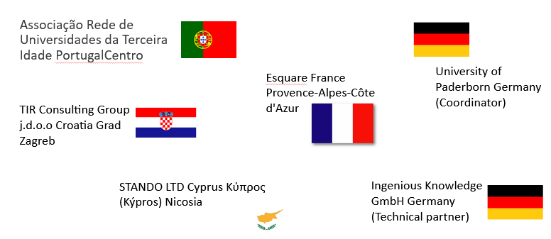

## 

## 2.2 The target group of EU-CERT

The target group for the EU-CERT project encompasses a wide range of stakeholders in the field of adult education. Primarily, it includes adult education providers who are directly involved in designing, delivering, and evaluating educational programs. These providers benefit from standardized accreditation and certification processes that ensure high-quality educational outcomes and enhanced recognition of their programs across Europe.

Additionally, the project targets policymakers and educational authorities who play a critical role in shaping and implementing education policies at the national and European levels. By providing a robust framework for accreditation, EU-CERT aims to support these stakeholders in promoting consistent and high standards across adult education initiatives.

Further, the project addresses the needs of adult learners who are the end beneficiaries of accredited and certified educational programs. Ensuring that these programs meet European standards enhances learners' confidence in the quality of their education and improves their mobility and employability across the European Union.

Moreover, organizations and institutions involved in ERASMUS+ projects find value in the accreditation tools and processes developed by EU-CERT. These entities are able to ensure that their project outcomes, including courses, modules, curricula, and training programs, are recognized and valued throughout Europe.

Lastly, the project aims to engage and benefit educational researchers and academic institutions involved in the study and development of adult education standards. By providing empirical data and a structured accreditation framework, EU-CERT contributes to the body of knowledge in this field and supports ongoing research and innovation.

In summary, the target group of EU-CERT includes adult education providers, policymakers, educational authorities, adult learners, ERASMUS+ project organizations, and educational researchers, all of whom stand to gain from the establishment of European standards for project accreditation and certification in adult education. To sum up the main target groups of the Erasmus+ project EU-CERT, the consortium addressed the following three categories of target groups by using different methods of dissemination strategies:

**Category learner, teacher and interested person:**

* Teachers in all educational fields
* Vocational trainers and HR developers in companies
* Vocational trainer in education administration
* Vocational training organizations and institutions
* Learners and students in all educational fields
* Interested person in teaching and learning online formats

**Category educational authorities, policy makers**

* Regional educational and VET authorities
* National authorities and policy makers
* European policy makers

**Researchers**

* Researchers at the international, European, national and regional level.

# 3. Project website

All information regarding the Erasmus+ project especially research results and outcomes as well as meetings information and meeting presentation and minutes are available at the EU-CERT project website: 

<https://eucert.eduproject.eu/>

# 4. EU-CERT Project Accreditation Tool

The EU-CERT Accreditation Tool aims at monitoring and assessment of adult education projects which leads to an accreditation or certification. The accreditation process is based on clear criteria and a solid accreditation system. Education providers can use this accreditation to prove their programmes of high quality. This way, education institutions can reach certain levels of quality. Throughout this process, the institution as well as employees can improve themselves and determine their quality.

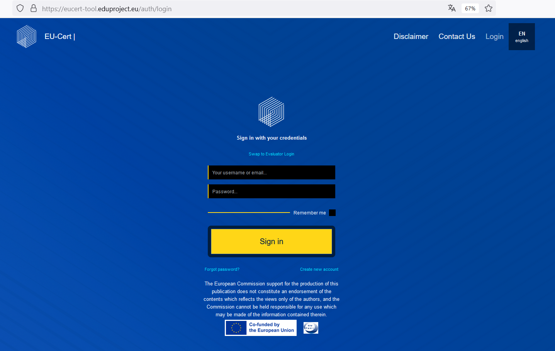 <https://eucert-tool.eduproject.eu/auth/login> 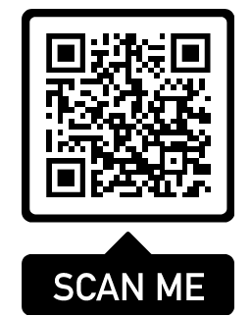

## 

# 5. EU-CERT on YouTube

### **EU-CERT: Ensuring Excellence in Renewable Technology**

EU-CERT, the European Certification and Evaluation of Renewable Technologies, is dedicated to standardizing and certifying renewable energy technologies across Europe. To aid stakeholders in understanding and navigating its certification processes, EU-CERT has produced a series of instructional videos. These videos cover various topics, including an introduction to EU-CERT, user registration, evaluator registration, institutional accreditation, and product accreditation. Each video provides clear, step-by-step guidance, ensuring that users, evaluators, institutions, and manufacturers can efficiently engage with EU-CERT’s rigorous standards.

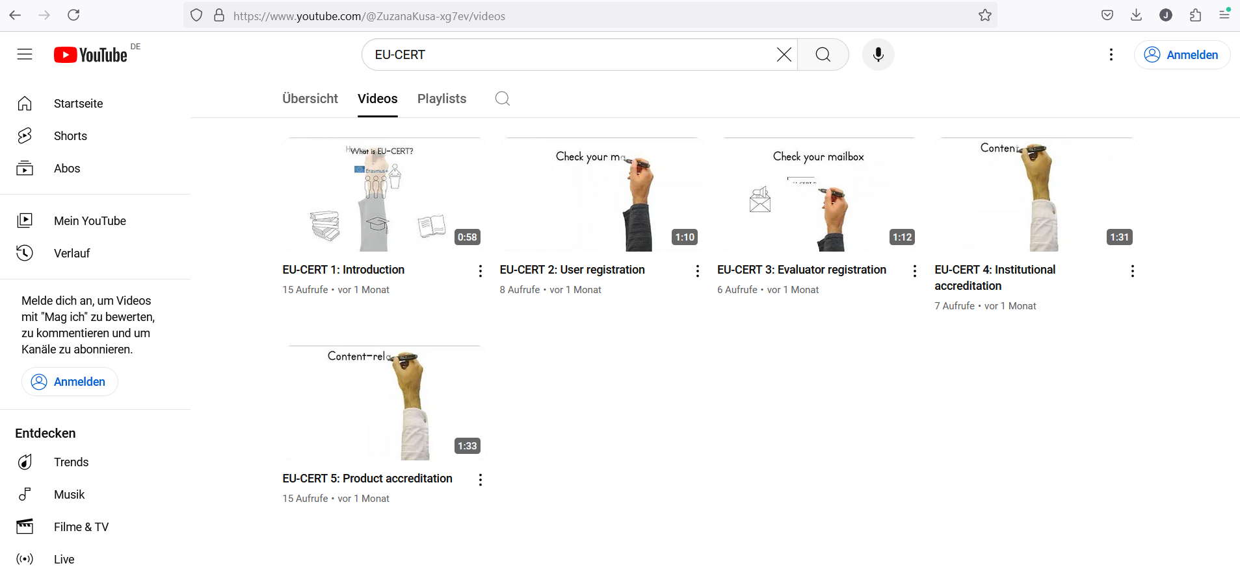

* Video: EU-CERT 1: Introduction

<https://www.youtube.com/watch?v=9iOtvEh6lhQ>

* Video: EU-CERT 2: User registration

<https://www.youtube.com/watch?v=HJbzKm8AsqY>

* Video: EU-CERT 3: Evaluator registration

<https://www.youtube.com/watch?v=mQM7xX0R7js>

* Video: EU-CERT 4: Institutional accreditation

<https://www.youtube.com/watch?v=Ppc7N7vVwSE>

* Video: EU-CERT 5: Product accreditation

<https://www.youtube.com/watch?v=TcCbNpK_Hf0>

# 

# 6. Dissemination Objectives

**General objective**

The Core dissemination and exploitation objective of a project is to maximise the impact of project results by optimising their value: by strengthening their impact, transferring them to different and new contexts, integrating them in a sustainable way and using them actively in systems and practices at local, regional, national, European levels as well as international background. Well-planned, structures and well-executed dissemination and exploitation ensure that project results have a reach beyond those directly involved in the consortium and an impact that is sustained beyond the project's lifetime by fostering the needs to ensure this aim.

The dissemination objectives of the EU-CERT project are centered around ensuring that the project's outcomes, tools, and standards are widely recognized, adopted, and implemented across the European adult education landscape. The key objectives include:

1. **Raising Awareness**:
   * Increase awareness among stakeholders about the importance and benefits of standardized accreditation and certification processes in adult education.
   * Highlight the project's goals, progress, and achievements through various communication channels to reach a broad audience.
2. **Engaging Stakeholders**:
   * Actively involve adult education providers, policymakers, educational authorities, and other relevant stakeholders in the project's activities.
   * Facilitate collaboration and knowledge exchange among stakeholders to promote the adoption of the developed accreditation standards and tools.
3. **Promoting Adoption**:
   * Encourage the integration of the EU-CERT accreditation and certification standards into existing adult education programs and policies.
   * Provide guidance and support to educational institutions and organizations in implementing the accreditation processes developed by EU-CERT.
4. **Ensuring Sustainability**:
   * Develop and share resources, such as the accreditation handbook and policy paper, to ensure that the project's outcomes are sustainable and continue to benefit stakeholders beyond the project's duration.
   * Establish a stable accreditation structure that remains functional and effective after the project's completion.
5. **Enhancing Visibility**:
   * Make the results and high-quality outcomes of ERASMUS+ projects more visible and valued through the dissemination of the EU-CERT standards.
   * Use the project's website, social media, publications, and events to showcase success stories and best practices.
6. **Providing Training and Support**:
   * Offer training sessions, workshops, and webinars to educate stakeholders about the accreditation process and the use of the developed tools.
   * Create a user-friendly accreditation website and database to facilitate easy access to information and resources.
7. **Fostering Policy Development**:
   * Influence policy development at the national and European levels by providing evidence-based recommendations and showcasing the project's impact on adult education quality.
   * Engage with policymakers to integrate the EU-CERT standards into broader educational policies and frameworks.
8. **Creating a Community of Practice**:
   * Build a network of practitioners, researchers, and institutions committed to maintaining high standards in adult education through continuous engagement and sharing of experiences.
   * Promote ongoing dialogue and cooperation among stakeholders to drive continuous improvement in adult education accreditation.

By achieving these dissemination objectives, the EU-CERT project aims to ensure that its innovative accreditation and certification processes are widely recognized, adopted, and sustained, ultimately enhancing the quality and credibility of adult education across Europe.

# 

# 7. Dissemination Strategies

The different categories of results may require different approaches for dissemination and exploitation. The plan includes 'scanning' activities that help partners identify a broader range of groups, as well as means to capture and respond to the needs of these groups.

**Dissemination**

Dissemination can be defined as a planned process of providing information to key parties on the quality, relevance and effectiveness of the results of programmes and initiatives. It occurs as and when the results become available. To achieve this, all EU-CERT partners employ all available means of communication to inform and convince all target groups about the quality, relevance and effectiveness of the EU-CERT project results, activities and educational material.

**Sustainability and Exploitation**

Sustainability and Exploitation are closely related, as sustainability is ensured by sustaining exploitation. Exploitation means *"making use of and deriving benefit from a result."* This means that sustainability is only guaranteed if the uses of, and benefits from, the project continue well beyond the project’s completion. This target is pursued, from the beginning, by all partners.

In the context of project results Exploitation primarily involves the two processes of 'mainstreaming' and 'multiplication', where:

- ***mainstreaming*** is the planned process of transferring the successful results of programmes and initiatives to appropriate decision-makers in regulated local, regional, national or European systems; and

- ***multiplication*** is the planned process of convincing individual end-users to adopt and/or apply the results of programmes and initiatives.

# 

# 8. Means of Dissemination

In previous sections the dissemination plan of the Erasmus+ project EU-CERT describes the target audience as follows:

* **Category learner, teacher and interested person**
* **Category educational authorities, policy makers**
* **Researchers**

Partners should employ all available means to reach these target groups. These means may be grouped into three main categories:

Online:

* The project website - used to disseminate the project activities and findings, as well as offer access to its final products.
* Distribution of digital newsletters, announcements and info via e-mail
* Use of online social networks to disseminate EU-CERT info and encourage members to visit the project website.
* EU-CERT on Facebook:



<https://www.facebook.com/profile.php?id=100083211711017>

Printed material:

* The production and targeted distribution of print material.
* The EU-CERT handbooks
* Publication of EU-CERT project information in newsletters, newspapers, magazines, etc.

Face-to-face:

* EU-CERT Multiplier Events in home countries of the EU-CERT project partners
* Meetings and Presentation in the University
* Communication and chat with interested learners and students after presentation in the University

Additionally, each partner strive to:

* publicise the project website
* publish information on the Erasmus+ project EU-CERT and its results on websites
* distribute digital newsletters, announcements, and information via e-mail
* use online social networks to disseminate information on the EU-CERT project and its results
* distribute print material at conferences and meetings
* publish information on the EU-CERT project and its results in (printed) newsletters, newspapers, magazines, etc.
* publish articles in local and international journals
* post info letters and invitations via regular mail
* engage users actively in the project

# Annex 1: Dissemination Log Template of EU-CERT